Bible Reading Guide 2020

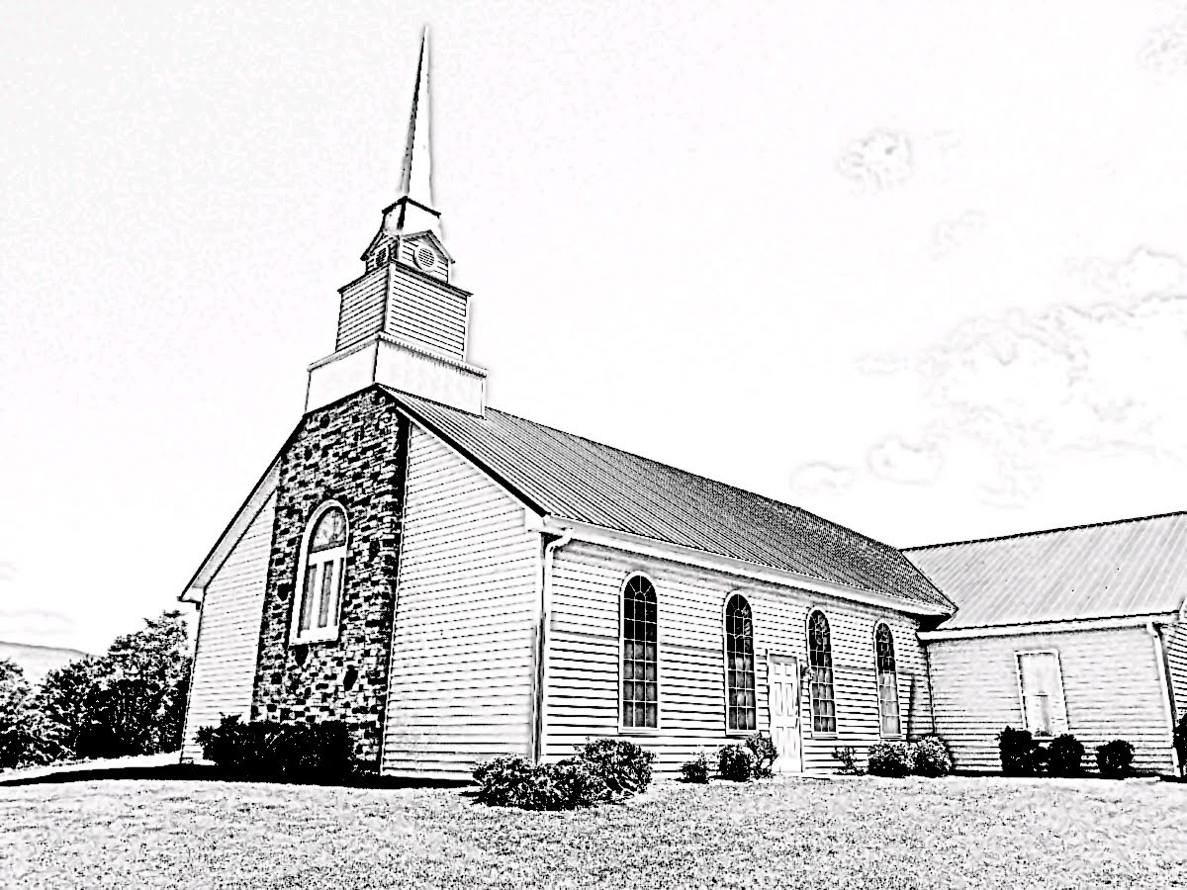
Week 11
March 8-14, 2020

Written by Rev. William F. Hill, Jr.
~Instructions~
- Pray
- Read the assigned text of Scripture.
- Answer the discussion questions as offered. Keep a notebook of your thoughts and answers.

Each chapter is a summary. It is not meant to be overly educational or intellectual. It is meant to give the reader a good thumbnail sketch of each chapter.

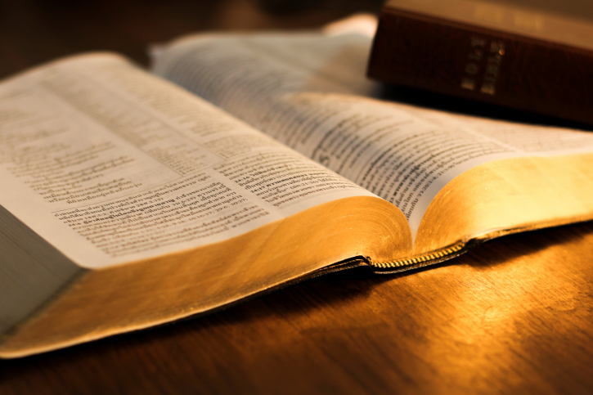

~Lord’s Day, March 8, 2020 ~
Reading: Psalm 19-20
PSALM 19
This Psalm is authored by David and is a classic Psalm that highlights “general revelation” as well as “special revelation.” A few words on both of these items.
General revelation is that means by which God has demonstrated his existence. It says nothing about what is required of man for eternal salvation. It merely demonstrates that God exists and that he is the alone creator of all things. Man is without excuse because they see this truth each day. The Westminster Confession of Faith 1.1 states, “Although the light of nature and the works of creation and providence do so far manifest the goodness, wisdom, and power of God to leave men unexcusable; yet are they not sufficient to give that knowledge of God, and of his will, which is necessary unto salvation.” (Rom. 2:14-15; Rom. 1:19-20; John 17:3; 1 Cor. 1:21, 2:13-14) . Simply stated, general revelation is expressed by what man can witness with their natural senses.
Special revelation, however, is that which explains general revelation. All mankind knows there is a God because they are made in his image, and he has proclaimed it to them daily. Special revelation explains God, his character, and attributes as well as his divine will and man’s need for salvation. Special revelation is given to us in the Word of God (66 canonical books). I{n days of old, God’s special revelation was communicated through visions, dreams, oracles, and the prophets. Now, due to the canon of the Scripture being complete, we have no other need for special revelation that the Spirit of God speaking in the Scriptures.
David, in this Psalm, treats both subjects in summary. Thus, the Psalm may be divided into two sections. The first (19:1-6) offers a summation of general revelation by using things that all mankind can see. The list is as follows: the heavens, the sky, and the sun. Note carefully the words used in 19:1, “The heavens declare the glory of God, and the sky proclaims his handiwork.” In short, God is preaching to all of humanity each day. What is he preaching? That he exists and that man, as his creatures are accountable to him. However, without special revelation, we would not know what to do with that information. That leads us to the second section of the Psalm.
In this section (19:7-14), David takes up the subject of special revelation, that is, the Word of God.
Discussion Questions:
- What is general revelation?
- What is special revelation?
- Why do we need special revelation to understand God’s plan of salvation?
- What items does David use to highlight general revelation?
- List the things that David says about God’s Word.
PSALM 20
This Psalm is a prayer and may be divided into two sections. The first section (20:1-5) is highlighted by the way each line of the Psalm begins with the word “may” (ESV). It is important to note the various things David (the author of the Psalm) prays.
The second section is a recording of the answer to the prayer.
Discussion Questions:
- What does the psalmist pray for in 20:1-5?
- How can you use these verses in your own prayer life?
- How does the LORD answer the prayer of the psalmist?
- Do you keep a written record of prayers and answers in a journal? It is a good practice.
~Monday, March 9, 2020 ~
Reading: Exodus 9, Acts 10
EXODUS 9
Exodus nine contains the record of the fifth, sixth, and seventh plague that the LORD brings against Egypt. In 9:1-7 is the plague that brought the livestock of Egypt to their deaths. Note that this plague was aimed only at the livestock of Egypt (see 9:4-6). The next plague in the chapter is that of the boils (9:8-12). The interesting element of this plague is how it affected the magicians of Egypt. That highlights their defeat that was pictured at the first encounter in 7:8-13. The final plague in this chapter is that of hail.
As in the other plagues, Pharoah appeared to relent and permit the people to leave, but as soon as the LORD ceased his wrath against the land, he resorted to his old, hardened ways.
Discussion Questions:
- Review plagues 1-4 and note their locations in the narrative.
- What are the three plagues in this chapter? What are the targets of these plagues?
- Why does God preserve the livestock of his people in the fifth plague? In evaluating your answer, consider the chapters to come, especially as they relate to sacrifices.
- Why are the magicians specifically mentioned in the sixth plague?
ACTS 10
Acts 10 begins with a record of a man of prayer who was visited by an angel of God. This event sets up the rest of the chapter. What is important to note is how Cornelius responded when an angel of God visited him. First, it appears to be a post-resurrection visit of the Savior (10:4). Second, note the response of Cornelius to the Lord (10:4). Third, note the instruction of the angel of God: “send men to Joppa and bring Peter. Fourth, note the obedience that follows the instruction.
The second section of the chapter is 10:9-33 contains some important items—first, the pronouncement that all foods are clean (10:15). Second, the intervention of the Spirit to accomplish the instructions of 10:1-8.
The third section of the chapter is 10:34-48 is a record of the Gospel coming to the Gentiles.
Discussion Questions:
- What is the main characteristic of the man named Cornelius? What does that teach you regarding prayer?
- Why does it seem reasonable that the “angel of God” is the risen Lord?
- Why does Peter resist eating the food that he saw in a vision? How does God relieve Peter’s concerns? What does that teach us regarding food today?
- What events does Peter review when he brings the Gospel to the Gentiles?
- What is the response of the Gentiles to the sermon of Peter?

~Tuesday, March 10, 2020 ~
Reading: Exodus 10, Acts 11
EXODUS 10
Exodus 10 contains the record of the eighth and ninth plague leveled against Egpyt. The first recorded plague of the chapter is that of the locusts (10:1-20). It comes first with a warning and is quickly followed by a refusal of Pharaoh to let the people go. This warning also comes with a plea from the servants of Pharaoh to let the people of God leave Egypt. All of it is resisted. Thus, the locusts swarmed the land and destroyed all vegetation in the land (what was left after the plague of the hail).
The second plague in the chapter – the penultimate plague against Egypt – is that of darkness. It came without warning. As before, Pharaoh refused to let the people go.
- Review the previous plagues and their location in the narrative.
- How does Pharaoh respond to this plague initially? Does it last?
- Pharoah’s response is an example of unbiblical repentance. True repentance is followed by obedience. He sinned, he is apologetic, but only due to the consequence and not to the command of the LORD.
ACTS 11
This chapter contains the inclusion of the Gentiles in the church. These Gentiles are those of the seed of the northern kingdom exiled in 722 BC by the Assyrian Empire. Peter’s behavior infuriates those of the circumcision party (11:1-3). He offers a defense and recounts the events that occurred in chapter 10. The important verse in this section is 10:18.
The second section of this chapter contains the events that led to the establishment of a church at Antioch. It is here that the disciples are first called “Christians.”
Discussion Questions:
- Why does Peter feel compelled to retell the events of chapter 10?
- What is the concern of the “circumcision party”?
- Why were the people of God scattered? What effect did that have on the advance of the Gospel?
- What role does the city of Jerusalem play in the early church?
- Where else in the New Testament in the word “Christian” used? Is the term used in a flattering way in Acts 11 or in a derogatory way?
~Wednesday, March 11, 2020 ~
Reading: Exodus 11, Acts 12
EXODUS 11
Exodus 11 records the events that lead to the final plague and, eventually, the institution of the Passover feast for the people of God. This warning of a final plague comes with an interesting instruction given by the LORD. Moses is told to tell the people to ask of the Egyptians for silver and gold jewelry. That will be important later in the book. The threat that is brought to Pharaoh is the death of the firstborn in all of the land --- including in the land of Goshen. Pharaoh refuses to hear the warning and this sets up one of the most important chapters in the book of Exodus.

Discussion Questions:
- Why does the LORD tell Moses to tell the people to ask of the jewelry?
- What is the warning of the final plague? What is the promise to Moses connected with the execution of the final plague? How does that differ from the other plagues?
ACTS 12
This chapter highlights the continued persecution of the people of God, especially to John and Peter. Herod, the king, is busy threatening and troubling the church and seizes John (the disciple, the brother of James) and has him executed. No other information is given. The chapter merely begins with a jarring statement regarding John’s execution. Peter is seized. The people of God pray, and Peter is released.
The chapter closes with a record of Herod, the king. As the chapter opens, he is busy troubling the church and killing John. At the close of it, Herod is killed, and we read that the “word of God increased and multiplied.” Persecution, while tragic, often advances the kingdom of God.
Discussion Questions:
- Why was Peter released from prison? That is, what means of grace was being employed? What does that teach you regarding that means of grace?
- Why was Herod killed by the angel of the Lord?
- Why does Mark close the chapter with the words of 12:25? It seems out of place? What is its purpose?

~Thursday, March 12, 2020 ~
Reading: Exodus 12, Acts 13
EXODUS 12
Exodus 12 is, arguably, the most important chapter in the book. It is vital to an overall understanding of the connection regarding the Exodus and how God delivered his people from Egypt. In this chapter, we have recorded the instructions regarding the celebration of the Passover Meal. It follows the warning of the final plague that will free the people of God from their slavery in Egypt. These instructions, if followed, will preserve a people from the impending doom that will fall upon the land.
The instructions regarding the Passover are important. This feat is the first year of the Jewish calendar and is to be celebrated on the tenth day of the month. Each household shall take a lamb (or if poor, secure help from a neighbor). The lamb must be without blemish. This instruction is a type that is fulfilled in the anti-type, the Lord Jesus Christ. At twilight of the fourteenth day of the month, the lamb shall be slaughtered, and the blood from the lamb placed on the doorposts of the house in which it is eaten. When the LORD sees the blood, he will pass over that home and not inflict the judgment of death on the firstborn. This typifies the work of the redemption of Christ.
At 12:21, Moses relates the instructions to the elders of Israel, and then the events of the final plague are recorded. At that point, the Exodus begins, and the people of God flee their captors.
At 12:43, further instructions are given regarding the Passover.

Discussion Questions:
- Why is the Passover so important in the life of God’s people?
- What does the blood represent? Why does God require the use of blood?
- Why a lamb without blemish? What does that picture?
- What is the overall picture of the Exodus as it relates to the people of God and His work for them?
ACTS 13
Acts 13 begins the missionary labors of Saul, who will be named Paul in this chapter.
The chapter has two main events introduced by the events at Antioch (13:1-3). In this introductory section, we note that the church set apart Barnabas and Saul for the “the work to which I have called them.” This work is unfolded throughout the chapter.
Section one (13:4-12) details the vents that happened in Cyprus. It is while ministering there that Saul’s name changes to Paul (13:9). The events center around the exchange between the magician and Paul.
Section two (13:13-52) details the events that happen at Antioch in Pisidia. This location is not to be confused with the Antioch of the opening verses. The most important section is the sermon that Paul preaches (13:16b-41). One of the striking aspects of this sermon is Paul’s use of the Old Testament. The response of the people is a cry for more of this kind of preaching (13:42-44). Through the labors of Paul and Barnabas, the whole city heard the Gospel, and many came to faith in Christ.
Discussion Questions:
- Why is the introductory section of this chapter important as it relates to the sending out of Paul and Barnabas? What does that teach the church regarding people who are self-proclaimed missionaries or pastors?
- What is the result of the work done in Cyprus?
- What is the result of the preaching of Paul in Antioch in Pisidia?
- Do you pray for success for the preaching of God’s Word?
~Friday, March 13, 2020 ~
Reading: Exodus 13, Acts 14
EXODUS 13
There are two main items to consider in this chapter. The first is the Feast of Unleavened Bread (14:3-16). This feast is subsumed under the Feast of Passover (12:14-20). This feast highlights the sanctifying work of the Spirit of God in the lives of the Redeemed people. Leaven is often a reference for worldliness and sinfulness, and it must be purged from the lives of the people. The Passover, indicting redemption, must precede this feast and what it represents. Only the redeemed of God can live godly lives.
The second section (13:17-22) describes the presence of God with the people as they set out from Egypt. By day, it was a pillar of cloud. By night, it was a pillar of fire. Later, this visible presence of God will be used to protect his covenant people.
Discussion Questions:
- Why must the Passover precede the Feast of Unleavened Bread?
- Define “redemption.”
- Define “sanctification.”
ACTS 14
Similar to Acts 13, this chapter describes the continuing missionary labors of Paul and Barnabas. In 14:1-7, they are at Iconium. It is while they were there that a division arose within the city, fueled by the hatred of the unbelieving Jews.
In 14:8-23, the two missionaries are laboring in Lystra, and it is here where Paul begins to experience the suffering that comes, inevitably, to God’s faithful servants.
The final section has the two missionaries returning to Antioch in Syria.
Discussion Questions:
- What fuels the anger of the unbelieving mind against the Gospel of Christ?
- How do the two missionaries respond to the opposition? Is that how you respond to opposition?
- Who (or what) does Paul and Baranablas oppose in the second section (14:8-18)? How do they answer these pagan practices?
- Why is Paul stoned? What narrative regarding Christ does 14:19 resemble?
~Saturday, March 14, 2020 ~
Reading: Exodus 14, Acts 15
EXODUS 14
Exodus 14 is the record of the Red Sea crossing. It is a well-known event in the Bible. There are a few items to note regarding it. First, note how God places the people in a bottle-neck? This is recorded in 14:1-4. The purpose of this action is that he might show his great power over the Egyptians and that his people might know that he alone is the one who fights for his people. God is jealous for his glory.
Second, God stirs and hardens the heart of Pharoah so that he pursues the people to accomplish his great plan and purpose to destroy the Egyptians.
Third, The people respond at the sight of the Egyptians in fear and complaining. This is a theme that will recur over and over in the life of the people. Note, however, then words of Moses in 14:14, “The Lord will fight for you.”
Fourth, note that God delivers the people using means (14:21). While it is true that the LORD fights for the people if Moses had failed to obey the voice of God, nothing would have been accomplished. Note also how the pillar of fire and cloud come into play in this battle with the Egyptians.
Discussion Questions:
- Why did God put the people in a bad location?
- Why do the people complain, especially after seeing the ten sign-plagues leveled against the Egyptians? We do the same thing. We see God work in our lives, and then, suddenly, a difficulty arises, and instead of remembering the goodness of God, we complain about our circumstance.
- What are the means that the LORD uses to bring the people safely across the Sea? How does God use means in the church today to accomplish his work?
- What would have happened if Moses had refused to obey the voice of the LORD? What happens to us if we refuse to use the means God has granted for the good of our soul?

ACTS 15
Acts 15 is the first meeting of the church to deal with a crisis that has arisen. In some sense, this is the first General Assembly or Presbyterian meeting of the early church. A few remarks on this meeting.
First, it was convened due to a problem and controversy (15:1-5). Simply put, the matter is over whether one has to be circumcised to be a Christian.
Second, the apostles and elders are gathered together to discuss the matter. This highlights that the church must make decisions under a governance of plurality of elders. (15:6-7a).
Third, note that Peter’s speech on the floor of the assembly is highlighted (15:7b-11).
Fourth, Paul and Barnabas offer a speech (15:12) followed by others. All of this demonstrates that the church is to be led by a plurality of elders and done so in a deliberative manner.
The assembly renders a decision and then sends it to all the churches (15:22-35). This highlights the connectedness of the churches.
Discussion Questions:
- How does Acts 15 highlight the church government known as Presbyterianism?
- What does the gathering of the elders conclude regarding the issue that was before them?
- Does Acts 15 give any room for independent churches?

