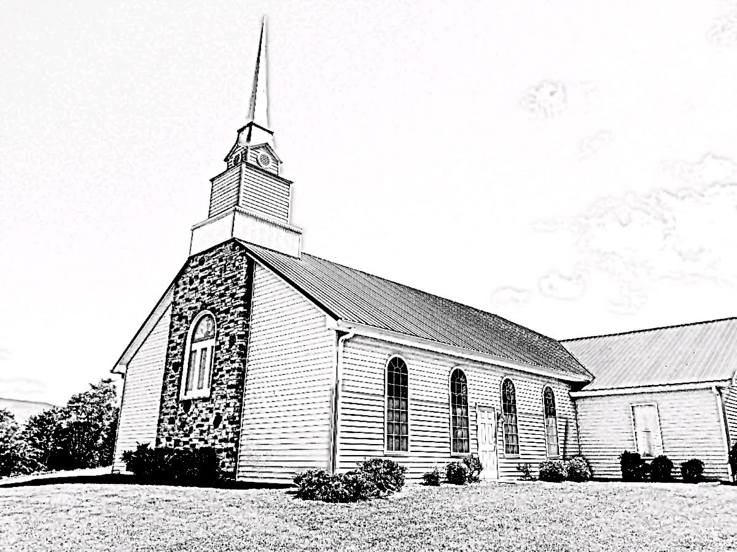
Fellowship Presbyterian Church
A Congregation of the Presbyterian Church in America
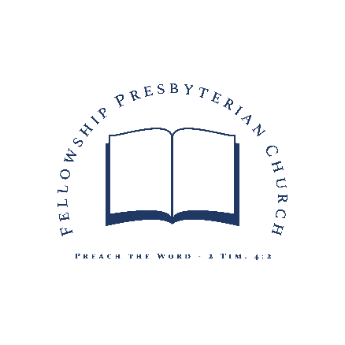
Lord’s Day ~ August 9, 2020
Rev. William F. Hill, Jr., Pastor
Morning Worship ~Lord’s Day~ August 9, 2020
~Worship in Praise~
Call to Worship Psalm 138:1-2
Prayer of Invocation
§Hymn #3 Give to Our God Immortal Praise
Hymn of the Month ~ Based on Psa. 136
~Worship in Confession~
Reading of Scripture Genesis 43
Confession of Sin See Page 3
Assurance of Pardon Ex. 34:6-7; Ps. 85:2
§Hymn #486 God Be Merciful to Me
Confession of Faith The Apostles’ Creed
See Page 4
~Worship in Gratitude and Thanksgiving~
Prayer of Thanksgiving RE Terry Rowekamp
§Doxology
~Worship and the Means of Grace~
Pastoral Prayer
Reading of Scripture Romans 13:8-14
The Preaching of God’s Word Rev. William F. Hill, Jr.
Walk Properly
§Hymn #537 Take Time to Be Holy
§Benediction

~Morning Worship – Confession of Sin~
Congregation:
Our Father in heaven, we bless your Name this morning. You are our God, and we are your people. We thank you that you have redeemed us and called us to yourself. We confess our sins to you, knowing that we often fall short of your glory. Help us to walk in your ways and obey you with our whole heart. We ask this, dependent on your grace and mercy that flows from your Son, the Lord Jesus Christ. Amen.
Assurance of Pardon:
The Lord, the Lord, a God merciful and gracious, slow to anger, and abounding in steadfast love and faithfulness, 7 keeping steadfast love for thousands, forgiving iniquity and transgression and sin; You forgave the iniquity of your people; you covered all their sin.
Exodus 34:6-7; Ps. 85:2, ESV

~Morning Worship ~ Confession of Faith~
The Apostles’ Creed
Minister/Ruling Elder:
What is it that you believe?
Congregation:

I believe in God the Father Almighty, Maker of heaven and earth.
I believe in Jesus Christ, His only Son, our Lord, who was conceived by the Holy Spirit and born of the virgin Mary. He suffered under Pontius Pilate, was crucified, died, and was buried; He descended into hell. The third day He rose again from the dead. He ascended into heaven and is seated at the right hand of God the Father Almighty. From there He will come to judge the living and the dead.
I believe in the Holy Spirit, the holy catholic¹ church, the communion of saints, the forgiveness of sins, the resurrection of the body, and the life everlasting. Amen

¹Note: the term “catholic” refers to the universal church of those who truly believe on the Lord Jesus Christ. It does not refer to the Roman Catholic Church.

~Church Announcements and Calendar~
- REMINDER: When you hear the piano playing, please find your seat and prepare for worship.
- If you are interested in becoming a member of Fellowship, please see the Pastor.
- REMINDER: the Session is calling a congregational meeting for Aug. 30th immediately after the AM Worship service to vote on the recommendation of the elders to elect Randall Sheetz to the office of Ruling Elder.
Lord’s Day, August 9, 2020
11 AM & 5 PM Worship | Lord’s Supper (AM Worship)
AM: Rom. 13:8-10 | PM: Judges 7:19-8:35
Tuesday, August 11, 2020
10 AM Radio Program on WLIK
Wednesday, August 12, 2020
6 PM Prayer Meeting and Bible Study
The Doctrine of Providence, part two
Lord’s Day, August 16, 2020
11 AM & 5 PM Worship
AM: Romans 14:1-4 | PM: Judges 9:1-21

~Prayer Needs~
Family of the week: Pastor Bill and Gwen Hill
Church of the week: Emmanuel Presbyterian (Franklin NC)
~Ushers, Greeters and Nursery Volunteers~
August Ushers: TBD
Greeter: TBD
Nursery: TBD
~Church Information~
Session: Terry Rowekamp (Clerk),
Rev. W. Hill, Jr. (Moderator)
Diaconate: William Hill, Sr. (treasurer)
Music: Mr. Randall Sheetz
Website: www.fellowship-pca.org
Mailing Address: PO Box 574, Newport TN 37822

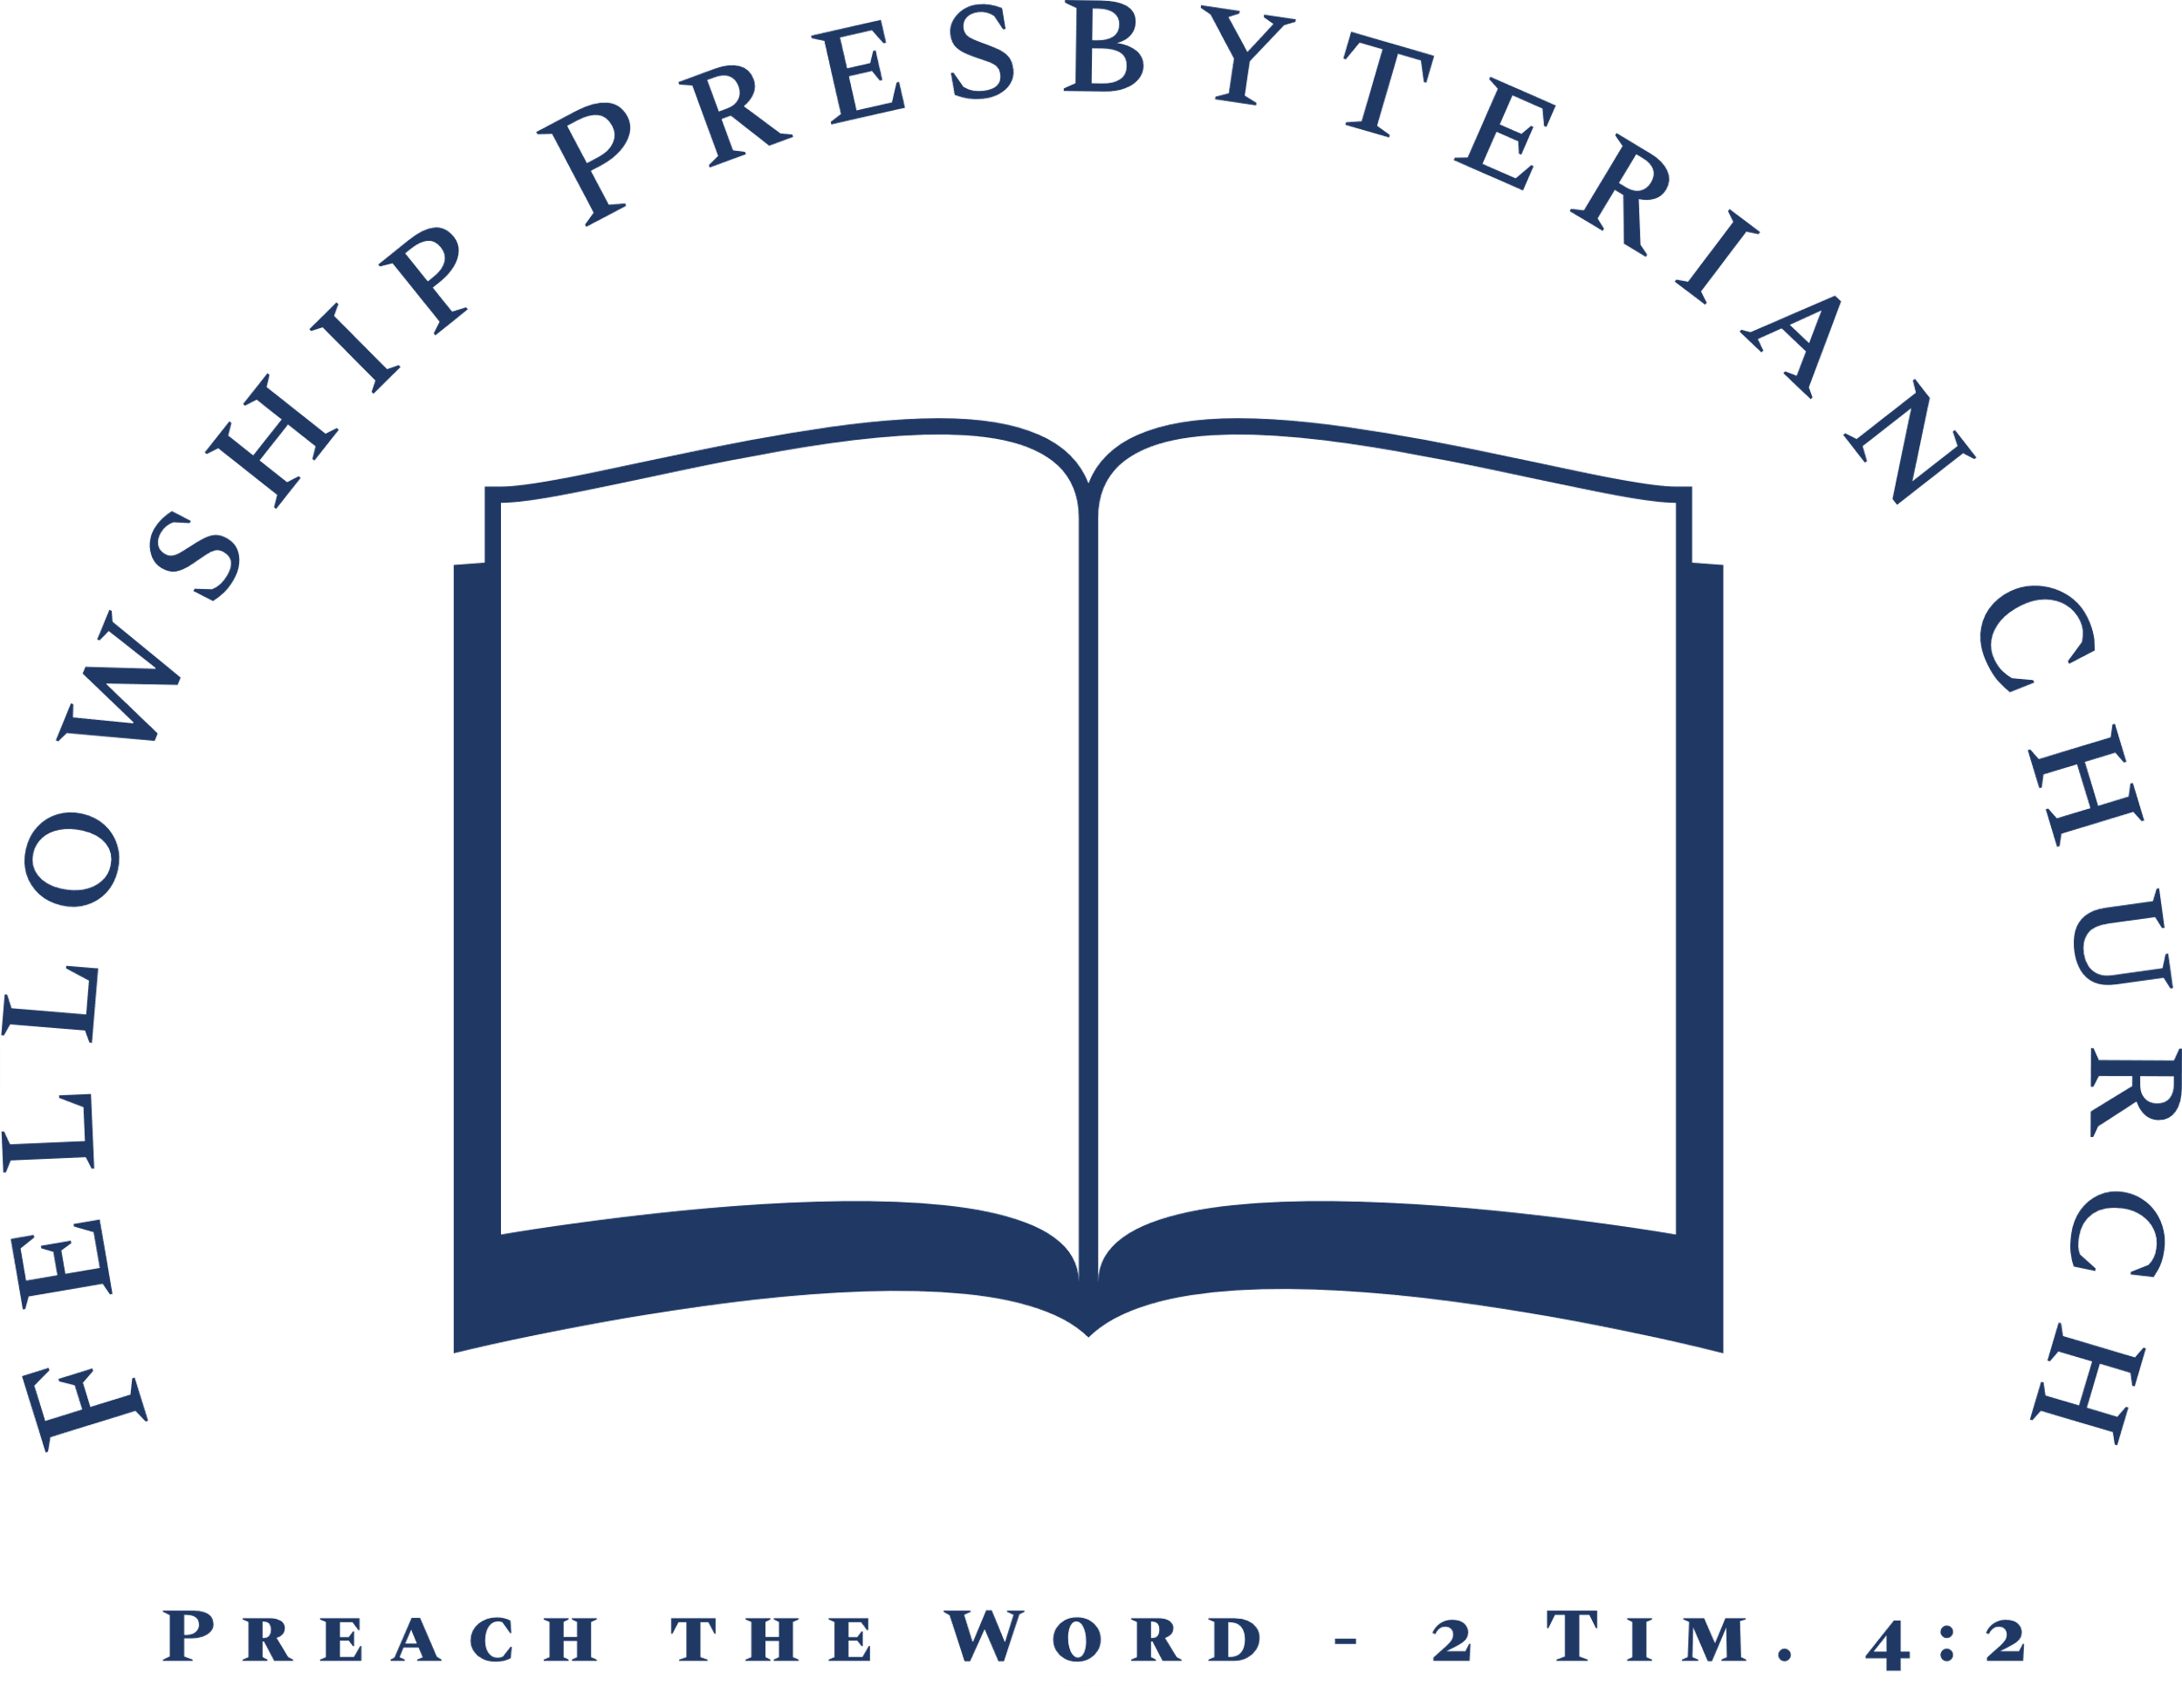
Evening Worship ~Lord’s Day~ August 9, 2020
~Worship in Praise~
Call to Worship Psalm 100
Prayer of Invocation and Confession of Sin
Hymn #5 God, My King, Thy Might Confessing
~Worship in Confession~
Confession of Faith The Nicene Creed
Trinity Hymnal, p. 846
Reading of Scripture John 6
~Worship in Gratitude and Thanksgiving~
Prayer of Thanksgiving Rev. William F. Hill, Jr.
Giving of Tithes and Offerings
Hymn #460 Amazing Grace
~Worship and the Means of Grace~
Pastoral Prayer and Prayer of Illumination
Reading of Scripture Judges 8:1-9
Sermon Rev. William F. Hill, Jr.
Gideon’s Mighty Victory
§Hymn #348 Jesus with Thy Church Abide
§Benediction

