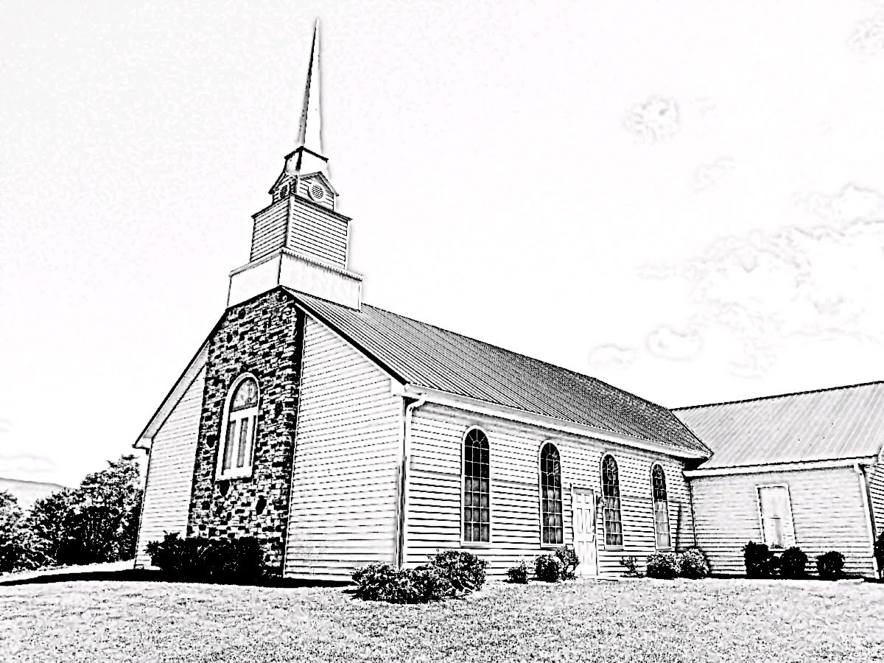

Nominating, Electing, and Installing Ruling Elders and Deacons

Fellowship Presbyterian Church

Every member of the church has the right and privilege to call their pastor, elder, and deacon, a privilege afforded the people by the rules governing the Presbyterian Church in America and the Word of God. However, with this privilege comes a great responsibility to carefully select a man that has been called apart by the Holy Spirit to fill the office of elder or deacon. This booklet will give guidance to the membership as to the importance, the offices, and the process of identifying, nominating, and electing an officer, and offer some practical suggestions at the conclusion.
THE IMPORTANCE
The office of elder or deacon is a spiritual office. No man declares themselves to be an elder [or deacon]. It is a work of the Holy Spirit who sets apart a man for the office. The elders and the congregation are how He accomplishes this work. That occurs when the body of believers corporately believe a man to be exercising the gifts given to him by the Holy Spirit to edify the body of Christ further and grow them in maturity and unity in the faith.
This process is serious. It is not to be taken lightly, and it should be entered by the candidate soberly. Likewise, the members of the church are to take up their responsibility seriously and soberly. The election of an officer in Christ’s church is not a popularity contest. It is done through the biblical qualifications as a church identifies a man that the Spirit of God has gifted to lead His people.
THE OFFICE OF ELDER
From the Book of Church Order (BCO) of the Presbyterian Church in America (PCA):
- This office [the office of elder] is one of dignity and usefulness. The man who fills it has in Scripture different titles expressive of his various duties. As he has the oversight of the flock of Christ, he is termed bishop or pastor. As it is his duty to be grave and prudent, an example to the flock, and to govern well in the house and Kingdom of Christ, he is termed presbyter or elder. As he expounds the Word, and by sound doctrine both exhorts and convinces the gainsayer, he is termed teacher. These titles do not indicate different grades of office, but all describe one and the same office.
- He that fills this office should possess a competency of human learning and be blameless in life, sound in the faith and apt to teach. He should exhibit a sobriety and holiness of life becoming the Gospel. He should rule his own house well and should have a good report of them that are outside the Church.
- It belongs to those in the office of elder, both severally and jointly, to watch diligently over the flock committed to his charge, that no corruption of doctrine or of morals enter therein. They must exercise government and discipline and take oversight not only of the spiritual interests of the particular church, but also the Church generally when called thereunto. They should visit the people at their homes, especially the sick. They should instruct the ignorant, comfort the mourner, nourish and guard the children of the Church. They should set a worthy example to the flock entrusted to their care by their zeal to evangelize the unconverted and make disciples. All those duties which private Christians are bound to discharge by the law of love are especially incumbent upon them by divine vocation and are to be discharged as official duties. They should pray with and for the people, being careful and diligent in seeking the fruit of the preached Word among the flock.
The office of elder is both “ministerial” and “declarative.” That is, the elder ministers the Word of God to the people in whatever circumstance is necessary, and declares the Word of God to the people. They are servants of the people, but the people are not their Master. Only the chief-shepherd, the Lord Jesus Christ is the Good Shepherd of the sheep and He, alone, is the King and Head of the church. Thus, as you evaluate men for the office of elder ask yourself, “Does that man have a servant's heart and is it displayed in his actions?”
Not only do you need to understand the nature and function of the office of elder, but you also need to understand the qualifications. The apostle Paul directs both Timothy and Titus on the qualifications for an elder. They can be found in 1 Tim. 3:1-7, and Titus 1:5-9. As you evaluate a man for the office of ruling elder, you are to do so under those qualifications. It is not about the perfection of the man, but it is about the consistent display of these items that is important.
As you prayerfully consider a man for this important calling ask yourself, “Would I be able to submit to him as my elder in the church?” Elders keep watch over the souls of Christ’s sheep. They have an important role in the life of the church, and they will give an account for you (Heb. 13:17).
Unlike the membership, an elder in the church must agree and support and defend the doctrinal standards of the church found in the Westminster Standards (the Confession of Faith, Larger and Shorter catechisms).
THE OFFICE OF DEACON
The functional difference between the office of elder and deacon is the focus. An elder is mostly concerned with the spiritual concerns of the congregation. A deacon is mostly concerned with the physical needs of the congregation. They are responsible for the building, the finances, and the physical needs of the people, both within the church and outside.

The PCA BCO is again helpful here:
- The office of deacon is set forth in the Scriptures as ordinary and perpetual in the Church. The office is one of sympathy and service, after the example of the Lord Jesus; it expresses also the communion of saints, especially in their helping one another in time of need.
- It is the duty of the deacons to minister to those who are in need, to the sick, to the friendless, and to any who may be in distress. It is their duty also to develop the grace of liberality in the members of the church, to devise effective methods of collecting the gifts of the people, and to distribute these gifts among the objects to which they are contributed. They shall have the care of the property of the congregation, both real and personal, and shall keep in proper repair the church edifice and other buildings belonging to the congregation. In matters of special importance affecting the property of the church, they cannot take final action without the approval of the Session and consent of the congregation. In the discharge of their duties the deacons are under the supervision and authority of the Session. In a church in which it is impossible for any reason to secure deacons, the duties of the office shall devolve upon the ruling elders.
- To the office of deacon, which is spiritual in nature, shall be chosen men of spiritual character, honest repute, exemplary lives, brotherly spirit, warm sympathies, and sound judgment.
As you prayerfully consider a man for the office of deacon you should consider the Biblical qualifications as listed in 1 Tim. 3:8-13.
Unlike the membership, a deacon in the church must agree and support and defend the doctrinal standards of the church found in the Westminster Standards (the Confession of Faith, Larger and Shorter catechisms).
THE PROCESS
The following is the typical process for nominating, training and electing an officer in the church. Some of these elements are required by the PCA BCO and noted below. Some of them are preferences born out of the nature and seriousness of the office. The process is as follows:
- The Session approves a season of nominations from the congregation. It should be specific (E.g., Aug. 1-31). BCO 24.1
- The congregation is instructed orally and in writing regarding the procedure to nominate a candidate(s):
  - The member prays about the man they would like to nominate.
  - The member evaluates the man considering 1 Tim. 3 and Titus 1. BCO 24.1
  - The member asks the person if he would be willing to serve as an elder (or deacon).
  - If the answer is in the affirmative, the nomination is submitted in writing to the pastor or a Ruling Elder.
  - The Session discusses and prays regarding the nomination. If the nomination is not approved (on biblical grounds only), then the nomination dies. If approved, the candidate(s) is (are) turned over to the pastor for training. BCO 24.1, a-e
    - Elder training – 12 weeks minimum.
    - Deacon training – 8 weeks minimum.
- Upon completion of the training period, the pastor either recommends or does not recommend the candidate(s) to the Session. If recommended, the Session meets with the candidate(s) for further questions and discussion, if necessary. BCO 24.1
- If the Session approves the recommendation of the pastor, the candidate(s) is (are) then recommended to the congregation to stand for election. BCO 24.1
  - The Session sets a date for a congregational meeting and an election of the candidate(s)
  - The congregation is informed as to the identity of the candidate(s).
  - The congregation is given the date (which must be at least 30-days notice) BCO 24.1
  - The congregation is exhorted as to their role in the process. NOTE: If the Session is presenting a candidate(s) to the congregation, they do so by recommendation. That means that your Elders believe the candidate(s) to be qualified for the office after vetting him and training him for that office. NOTE: If you believe you must vote “no” (on biblical grounds only), then you should speak with the candidate(s) before doing so. (Matt. 18, Gal. 6:1).
- The election process:
  - Secret ballot election. BCO 24.4
  - Only members may vote. BCO 24.3
  - The vote is counted, and the recommendation of the session is either sustained or denied. No specifics are to be given at the meeting. Recommend that the Session agrees with the candidate(s) that no elder or deacon will be elected if they do not secure at least an 80 percent affirmative vote. [NOTE: The BCO only requires a majority].
  - All ballots are destroyed.
  - The candidate(s) is (are) informed of the decision of the congregation.
  - An installation date is set for the Elder-elect [or Deacon-elect]. BCO 24.6

CONCLUSION
A summary of what has been discussed in this booklet on this very important topic is as follows:
- The office of elder and deacon is spiritual in nature. It is an office that the Holy Spirit grants to a man and gifts him to perform that office.
- The congregation identifies a man for the office of elder or deacon. No man declares himself to be an officer in the church without the confirmation of the people of God.
- The congregation has the right to prayerfully, with great sobriety, nominate and elect their officers in the church. Any member in good standing of the church can nominate men they believe qualified and called to the office during the nominating period assigned by the Session.
- If the nomination is sustained by the Session, the individual is trained towards the office he is seeking to enter.
- If the candidate(s) are biblically qualified, the pastor of the church recommends the candidate(s) to the office he is seeking to enter.
- The Session, upon approval of the recommendation of the pastor, recommends the candidate(s) to the congregation.
- The congregation meets for an election after a 30-day waiting period. An election is held, and the recommendation of the Session is either approved or denied.
- If the candidate is approved and voted into the office of ruling elder or deacon, a date is set for installation and ordination to the office that the Holy Spirit has given to him.

