Bible Reading Guide 2020

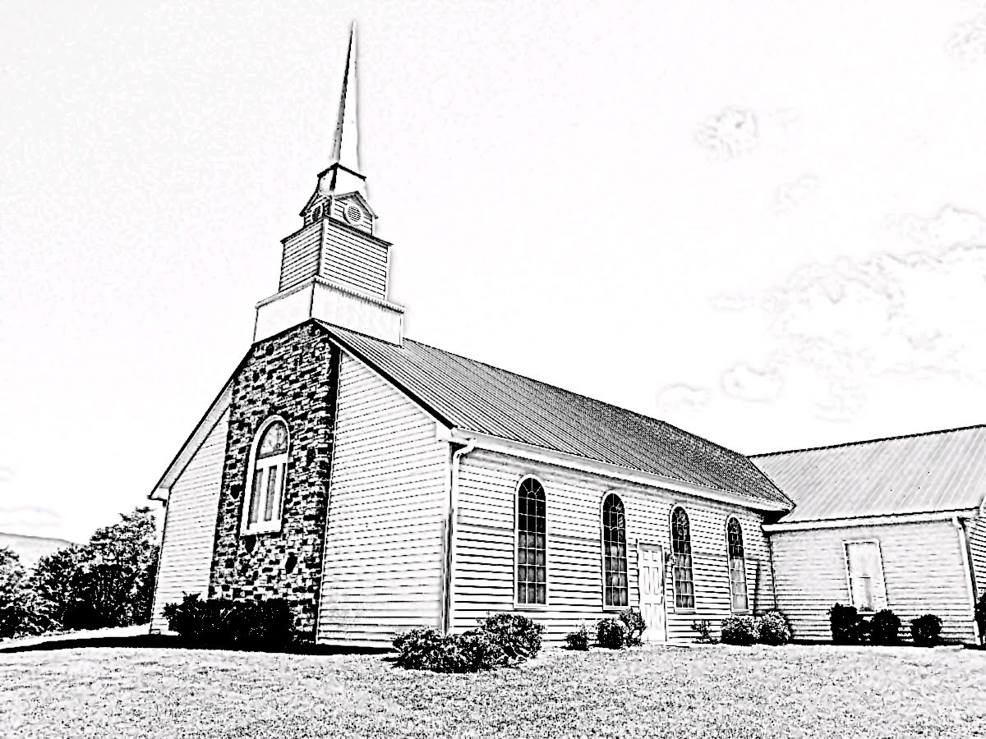
Week 9
February 23-29, 2020

Written by Rev. William F. Hill, Jr.
~Instructions~
- Pray
- Read the assigned text of Scripture.
- Answer the discussion questions as offered. Keep a notebook of your thoughts and answers.

Each chapter is a summary. It is not meant to be overly educational or intellectual. It is meant to give the reader a good thumbnail sketch of each chapter.

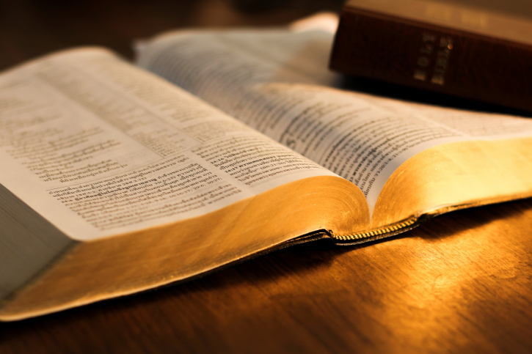

~Lord’s Day, February 23, 2020 ~
Reading: Psalm 15-16
PSALM 15
Psalm 15 contains a topic that is often seen throughout the Old Testament: mountain theology. David opens with a simple yet profound question: Who shall sojourn in your tent? Who shall dwell on your holy hill? Though there are two questions, it is one in substance. The issue revolves around who may be in YHWH’s presence. The tent is referring to the tabernacle, the place of God’s presence and glory. The holy hill refers to that place where God first met with his people (Ex. 19).
The Psalmist lists a catalog of items that, if lived properly, allows one to dwell with YHWH.
Discussion Questions:
- Identify each of the items listed in the Psalm and come up with a short definition or explanation for each.
- Is this catalog of items a complete record of ethical characteristics about the one who may dwell with YHWH? Why or why not?
- Is any mere man able to perfectly perform all of these items? How does the Psalm point the reader to Christ?
PSALM 16
Psalm 16 highlights the concern of the writer – past or present. The Psalm can be divided into two sections. The first (16:1-6) highlights the issue as introduced with the words “preserve me.” The second section (16:7-11) is a section of praise and reflection on the goodness of the LORD.
- Why does the writer say that apart from the LORD, he has no good? (16:2).
- Why is it a sorrowful thing for people to run after other gods?
- Re-read 16:8-9. The writer is declaring something. What is it?
~Monday, February 24, 2020 ~
Reading: Genesis 47, John 19
GENESIS 47
This chapter contains the events that bring Joseph’s family into Goshen. The people of Jacob’s household were required to settle there due to the Egyptian’s attitude regarding shepherds. (47:1-6). What is of interest in this chapter is to note how the lesser blesses the greater. Typically, it is the other way around. Not here. A few years from now, this situation will be reversed when the people of Jacob’s household are forced into slave labor.
A final observation – Jacob made Joseph swear that he would not bury him in Egypt. Here we see another exile and return theme. Currently, Jacob and his family are exiles in Egypt due to the famine. Many years from now, they will return to the land.
Discussion Questions:
- Why do you think the Egyptians considered shepherds with a poor attitude?
- How long did Jacob live in Egypt?
- Why does Jacob desire to be buried in Canaan?

JOHN 19
This chapter contains the events that lead to the crucifixion of the Savior. The opening verses of the chapter find Jesus before Pilate, the Roman governor (19:1-16). A few items are worth noting. First, the chapter is a response to the events that took place at the end of chapter 18. Second, John notes that it is the “chief priests and the officers” who shouted, “crucify him.” Third, note the verdict of Pilate: “I find no guilt in him.” A remarkable statement given the fact that Pilate still turned him over to be crucified (19:16). Clearly, Pilate was swayed by the crowd and the officials. Fourth, note how Jesus demonstrates to Pilate where true sovereign authority resides (19:11).
The crucifixions account is given in 19:17-37 and leads to the burial of the Savior (19:38-42).
Discussion Questions:
- Why do you think Pilate caved into the will of the mob?
- What does 19:11 teach regarding world leaders today and their actions?
~Tuesday, February 25, 2020 ~
Reading: Genesis 48, John 20
GENESIS 48
This chapter contains the narrative of Jacob blessing the two sons of Joseph. These two sons fill out the twelve tribes of Israel. Sometimes these tribes are referred to as “Joseph,” but usually they are found individually, especially in the historical books.
The important item to note in this chapter is how the storyline of the “younger being blessed by the older” is demonstrated. Once again, and similar to the events of Jacob and Esau, the younger receive the greater blessing over the older. This is a storyline that will continue into the historical books.
Discussion Questions:
- Why did Joseph go to his father?
- This chapter precedes the one in which Jacob blesses the rest of his sons. Do you think there is any significance to that fact?
JOHN 20
John 20 chronicles the events surround the resurrection of the Savior. What is important to note is that this chapter is post-resurrection. That is, these are the things that happened after the Savior had already been resurrected. Observe, first, that it was Mary Magdalene that went to the tomb. Upon arriving, she saw that the stone had been removed. She then goes to tell Peter and the “other disciple” (probably John, the author of the Gospel). Peter and John return to the tomb and see the same thing. John is more careful, but Peter, as usual, rushes in and sees that the Savior is gone. They then return home. However, Mary, who was still at the tomb, receives a visit from the Savior. (20:1-18).
The next section of the chapter contains the events that surround Jesus’ visit to his disciples. It is here that they receive the Holy Spirit, though Thomas doubted. He does believe, eventually, and falls and worships the risen Lord.
Discussion Questions:
- Why is the doctrine of the resurrection vital to Christianity?
- Why does John mention the first day of the week twice in this passage? See 20:1 and 20:19.
- What is the purpose of the Gospel of John?
~Wednesday, February 26, 2020 ~
Reading: Genesis 49; John 21
GENESIS 49
This chapter contains the account of Jacob blessing his sons. Each one of these blessings is significant and will prove interesting as the historical record is unfolded in the era to come. Additionally, this chapter records the death of Jacob.
- Read through the blessings offered and see if you can identify certain traits that will be unpacked in the historical books.
- Where was Jacob buried? Why is that important?
JOHN 21
This chapter contains the record of Jesus appearing to some of his disciples after his resurrection. The important point of the chapter is the interaction Jesus has with Peter. A few things to note: First, this proves that Peter was restored after his denial of Christ. Second, this demonstrates the grace of the Savior, his willingness to restore Peter, and his desire to use Peter in the work of the Gospel. Shortly after Christ ascends to his Father, Peter will preach one of the most important sermons in the life of the church (Acts 2).
Discussion Questions:
- What were the disciples doing when Jesus appeared to them?
- How many times does Jesus ask Peter if he loves him? Why three times? What is Peter’s response?

~Thursday, February 27, 2020 ~
Reading: Genesis 50, Acts 1
GENESIS 50
This chapter records the events that occur immediately after the death of Jacob. What is important to note is the concern of the brothers, now that their father is dead. They are worried that Joseph may seek retribution for their mistreatment of him. In a very Christlike move, Joseph responds with grace and forgiveness to them. The most important verse in this chapter is 50:20.
- What is the lesson of 50:20? How should that govern our lives?
- What should be your attitude towards those enemies in your life?
ACTS 1
The book of Acts is considered to be the second volume of the gospel writer, Luke. It is addressed to the same individual as the gospel. The book should be called “The Acts of the Holy Spirit” because that is precisely what is recorded throughout the twenty-eight chapters.
The opening chapter contains the record of Jesus' final meeting and discussion with the disciples and the ascension (1:1-11). Second, it contains the record of the choosing of Mathias to replace Judas as the 12th disciple (1:12-26).
Discussion Questions:
- Why is the book of Acts the second volume of Luke? See Luke 1:1-2.
- Why is the title “The Acts of the Holy Spirit” preferred?
- What is the teaching of Jesus to the disciples before he ascends? Acts 1:6-8.
- Luke gives a clue as to how to outline the book in 1:8. How does he do that?
~Friday, February 28, 2020 ~
Reading: Exodus 1, Acts 2
EXODUS 1
The book of Exodus is the second book of Moses and highlights the work of God redeeming a people from bondage. It pictures the redeeming work of Christ for sinners in freeing them from sin and slavery.
The opening chapter contains the background regarding the people of God and the new Pharaoh in Egypt. Until now, God’s people enjoyed protection and prosperity under the guidance of a different Pharaoh and the leadership of Joseph. Now, Joseph is dead, and a new Pharaoh is on the throne. The book opens with words designed to get the reader's attention (1:8).
The chapter can be divided into two sections. The first (1:1-7) gives some background and context. The second (1:8-22) introduces the narrative that will continue for the next twelve chapters.
Discussion Questions:
- Compare 1:6 and 1:8. How do these two verses set up the struggle that will occur for the next twelve chapters?
- How does this new Pharaoh treat the people of God?
- How does the new Pharaoh deal with the newborn sons of the Hebrews? See 1:15-22. Compare with Matt. 2.
- Why did the midwives ignore the command of Pharaoh?
- How did God protect the children of his people in this chapter?
ACTS 2
This chapter is the record of the sermon of Peter. Read it carefully. Two items to note for the life of the church. First, preaching must be a priority (2:14-41). Second, prayer must also be a priority, specifically, corporate prayer (2:42-47).
Discussion Questions:
- What does Peter often use throughout his sermon to make his point?
- What event precedes the sermon? 2:1-4.
- What happens as a result of the sermon?
- How does this chapter highlight the vital importance of preaching and corporate prayer? Are you zealous to be in attendance whenever the Word of God is preached? Do you attend the corporate prayer meetings of the church?
~Saturday, February 29, 2020 ~
Reading: Exodus 2; Acts 3
EXODUS 2
Exodus 2 is divided into three sections. The first (2:1-10) contains the birth and protection of Moses. Moses is the most important figure in the Bible apart from Christ. It is important to note here that Moses is not the oldest son. That theme began in Genesis (E.g., Jacob, and Esau) and will continue throughout the Old Testament (E.g., David).
The second section (2:11-22) contains the events that force Moses to flee to Midian. It is there that Moses will learn in the school of Christ for forty years.
The third section (2:23-25) reminds the readers that God is mindful of his people and knows their struggle.

Discussion Questions:
- How does God protect Moses in this chapter? There are two specific ways in which he does so. Note them.
- What occupation does Moses take up as a result of fleeing to Midian? Why is that important in his life?
- Why are the people groaning in Egpyt? Considering the nature of sin, what does that teach you regarding it, and how is it resolved?
- The final verse of the chapter is striking: “God saw the people of Israel – and God knew. It introduces the events that will follow. How?
ACTS 3
This chapter is divided into two sections of the apostles; both of them led by Peter. The first (3:1-10) contains the record of the healing of the lame man. It is important to note the events and the reaction of the people. Second (3:11-26) contains another sermon addressed to the people who witnessed the healing.
Discussion Questions:
- Where does the healing take place? What does that tell you regarding the current missionary work of the apostles thus far?
- How do the people respond to the healing? How does this response parallel the response people had when Jesus was ministering on earth?
- Why does Peter take this opportunity to preach? What does that teach you regarding the priority of the preached word over miraculous works?
- How do the people (the leaders, see 4:1) respond to the sermon? How does that parallel the response of the leaders to the preaching of Christ while he ministered on earth?
- Embedded in this chapter are two practical lessons. First, people will usually respond well to miraculous events. Second, people typically do not respond as well to the preached Word. Things have not changed much in the 21st century. People typically respond well to anything as long as you do not preach the Word of God to them.
