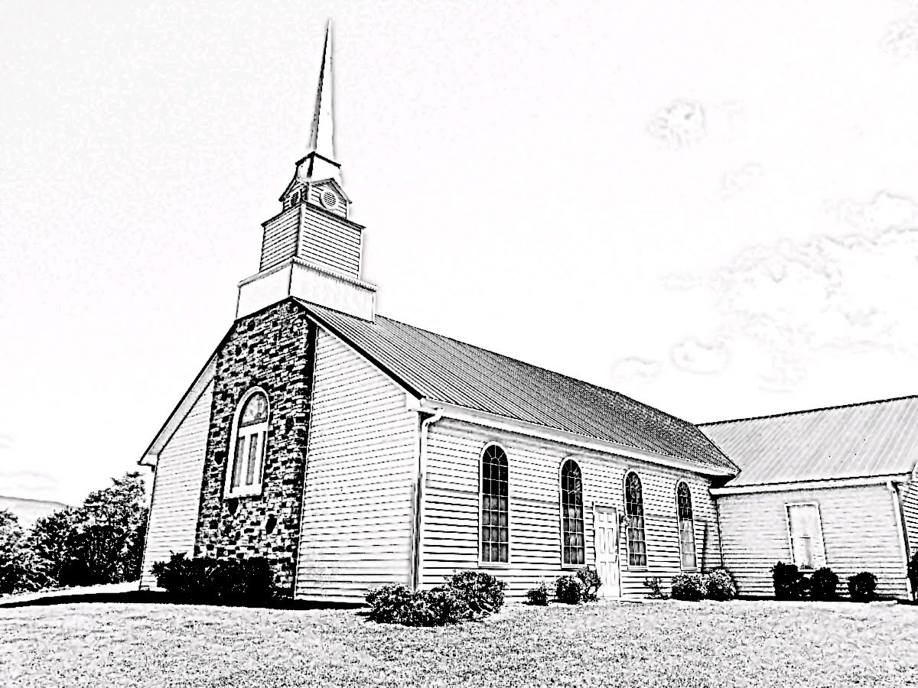
Fellowship Presbyterian Church
A Congregation of the Presbyterian Church in America
Lord’s Day ~ February 16, 2020

Rev. William F. Hill, Jr., Pastor

Morning Worship ~Lord’s Day~ February 16, 2020
~Worship in Praise~
Call to Worship Psalm 100
Prayer of Invocation
§Hymn #55 To God Be the Glory
~Worship in Confession~
Reading of Scripture Genesis 25
Confession of Sin See Page 3
Assurance of Pardon Titus 3:5-7
§Hymn #471 ‘Tis Not That I Did Choose Thee
Hymn of the Month
Confession of Faith Westminster Shorter Catechism Q23-24
See Page 4
~Worship in Gratitude and Thanksgiving~
Prayer of Thanksgiving RE Terry Rowekamp
Giving of Tithes and Offerings
§Doxology
~Worship and the Means of Grace~
Pastoral Prayer and Lord’s Prayer
Reading of Scripture Hebrews 7:1-10
The Preaching of God’s Word Rev. William F. Hill, Jr.
The Eternal Priesthood of Christ, Part One
§Hymn #246 Man of Sorrows! What a Name
§Benediction
~Morning Worship – Confession of Sin~

Congregation:
Our Father in heaven, glorious in majesty, we gladly come to you. As your children, we bow before you this morning, humbled at our condition as creatures of dust. We are often ashamed of the darkness of our hearts. We grieve our sins, our shortcomings, our transgressions. How often we fail to love you with all of our hearts. We frequently ignore the needs of our neighbors. Forgive us and cleanse us for all of our sins. We pray this in Christs’ Name. Amen.
Assurance of Pardon:
He saved us, not because of works done by us in righteousness, but according to his own mercy, by the washing of regeneration and renewal of the Holy Spirit, whom he poured out on us richly through Jesus Christ our Savior, so that being justified by his grace we might become heirs according to the hope of eternal life.
Titus 3:5-7, ESV

~Morning Worship ~
Westminster Shorter Catechism Q23-24

Minister/Elder: Q. 23. What offices doth Christ execute as our redeemer?

A. Christ, as our redeemer, executeth the offices of a prophet, of a priest, and of a king, both in his estate of humiliation and exaltation.

Minister/Elder: Q. 24. How doth Christ execute the office of a prophet?
A. Christ executeth the office of a prophet, in revealing to us, by his word and Spirit, the will of God for our salvation.

~Church Announcements and Calendar~
- The Bible Reading Guide for Feb. 16-22, 2020, is available on the table in the hallway.
- The Next Ladies Meeting will be held on Feb. 22 at 9 AM (Breakfast) and 10 AM (Discussion). Sign-up sheet on the table in the hallway. Please see Gwen Hill if you have questions.

Lord’s Day, February 16, 2020
9:45 AM Sunday School
Corporate Worship
11 AM & 5 PM Worship
AM: Hebrews 7:1-10 | PM: Judges 2:1-5
Tuesday, February 18, 2020
10 AM Radio Program on WLIK
Wednesday, February 19, 2020
6 PM Prayer Meeting and Bible Study
Study: The book of Leviticus
Thursday, February 20, 2020
10 AM Session Meeting
Saturday, February 22, 2020
9 AM Ladies Breakfast
9 AM Western Carolina Presbytery (Hendersonville NC)
10 AM Ladies Meeting
Lord’s Day, February 23, 2020
9:45 AM Sunday School
Corporate Worship
11 AM & 2 PM Worship
AM: Hebrews 7:11-19 | PM: Judges 2:6-23
12:30 PM Fellowship Meal at the Church

~Prayer Needs~
Family of the week: John and Barbara Slaven
Church of the week: Emmanuel Presbyterian (Franklin NC)
~Ushers, Greeters and Nursery Volunteers~
February Ushers: Daniel Zellers and William Hill, Sr.
Greeter: Rob Amick
Nursery: TBD
~Church Information~
Session: Terry Rowekamp (Clerk),
Rev. W. Hill, Jr. (Moderator)
Diaconate: William Hill, Sr. (treasurer)
Music: Mr. Randall Sheetz
Website: www.fellowship-pca.org
Mailing Address: PO Box 574, Newport TN 37822

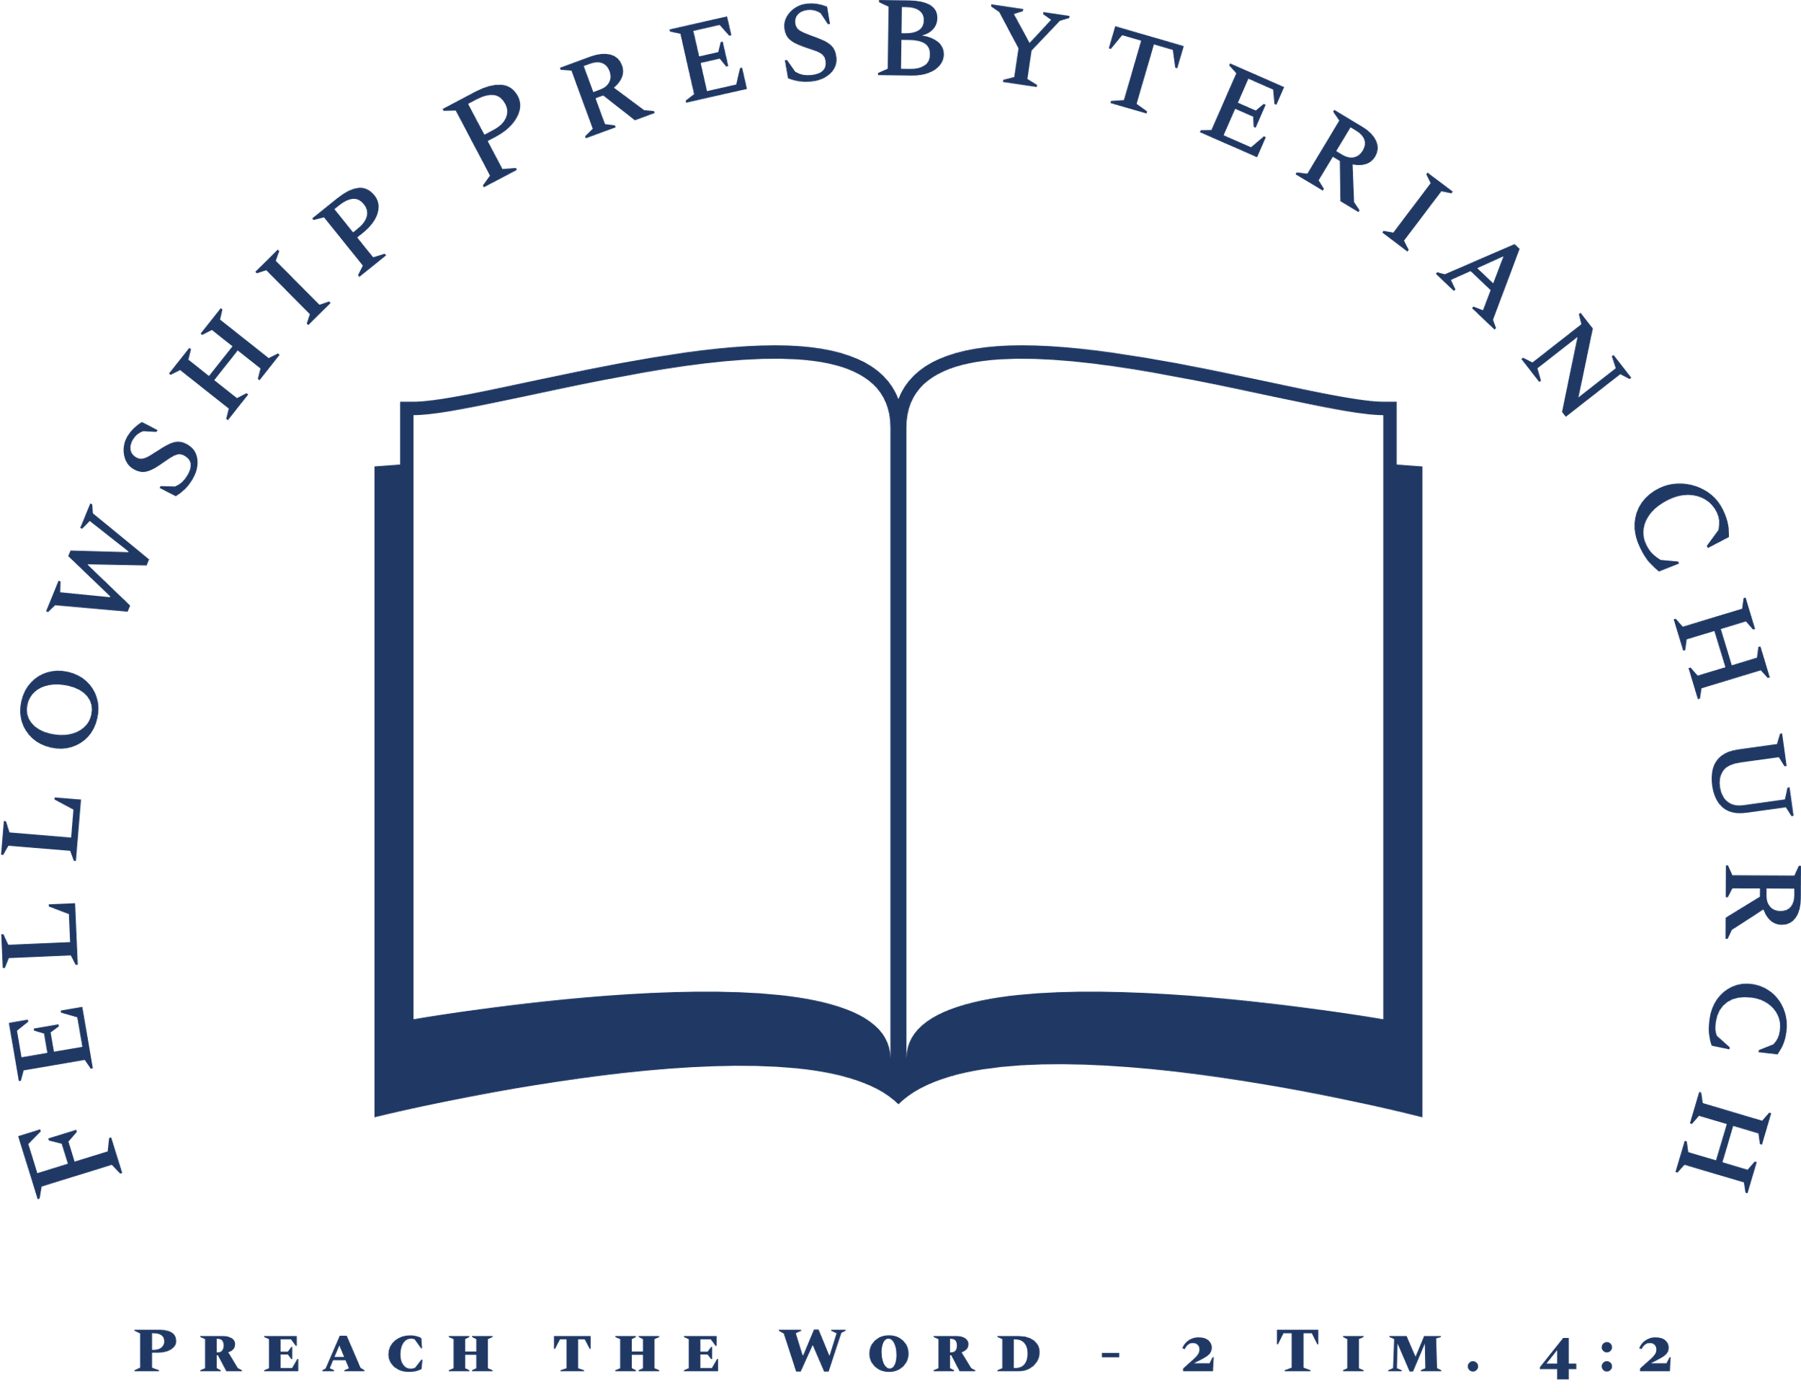
Evening Worship ~Lord’s Day~ February 16, 2020
~Worship in Praise~
Call to Worship Psalm 145:1
Prayer of Invocation and Confession of Sin
Hymn #5 God, My King, Thy Might Confessing
~Worship in Confession~
Confession of Faith The Apostles’ Creed
Trinity Hymnal, p. 845
Reading of Scripture Matthew 19
Hymn #32 Great Is Thy Faithfulness
~Worship in Gratitude and Thanksgiving~
Prayer of Thanksgiving Rev. William F. Hill, Jr.
Giving of Tithes and Offerings
~Worship and the Means of Grace~
Pastoral Prayer and Prayer of Illumination
Reading of Scripture Judges 2:1-5
Sermon Rev. William F. Hill, Jr.
Disobedience, Judgement, and Repentance
§Hymn #457 Come, Thou Fount of Every Blessing
§Benediction

