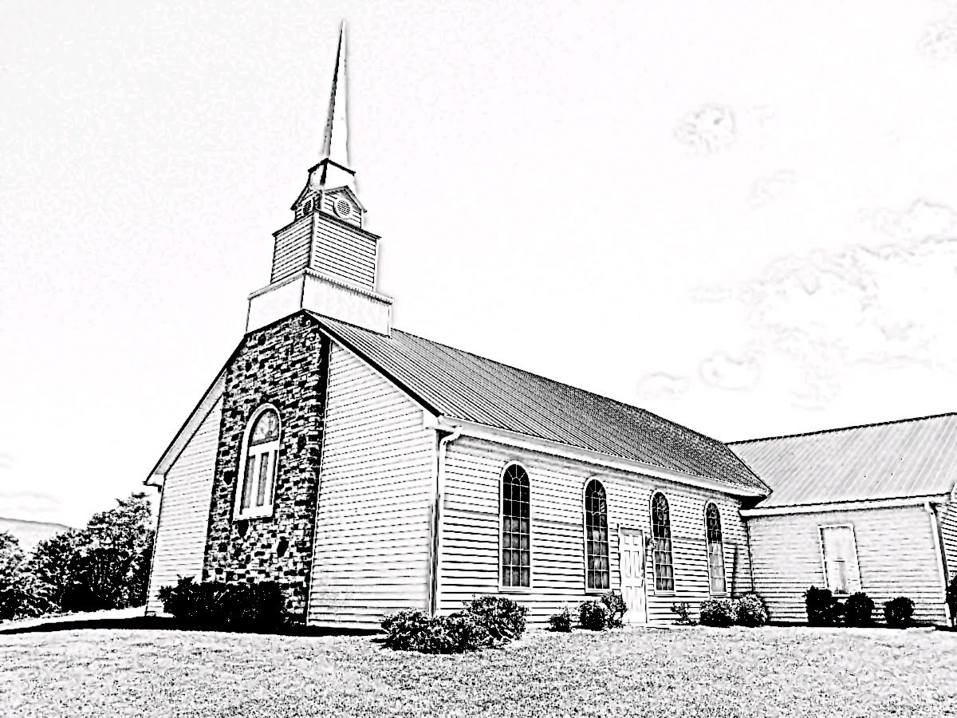
Fellowship Presbyterian Church
A Congregation of the Presbyterian Church in America
Lord’s Day
December 8, 2019

Rev. William F. Hill, Jr., Pastor

Morning Worship ~Lord’s Day~ December 8, 2019
~Worship in Praise~
Call to Worship Psalm 135:1-2
Prayer of Invocation
§Hymn #38 Immortal, Invisible, God Only Wise
~Worship in Confession~
Reading of Scripture Genesis 17
Confession of Sin See Page 3
Assurance of Pardon 1 John 2:12
§Hymn #590 Jesus, Master, Whose I Am
Hymn of the Month
Confession of Faith Shorter Catechism Q23, 25
See Page 4
~Worship in Gratitude and Thanksgiving~
Prayer of Thanksgiving RE Terry Rowekamp
Giving of Tithes and Offerings
§Doxology
~Worship and the Means of Grace~
Pastoral Prayer and Lord’s Prayer
Reading of Scripture Hebrews 4:14-16
The Preaching of God’s Word Rev. William F. Hill, Jr.
Our Sympathetic High Priest
§Hymn #306 Jesus, My Great High Priest
§Benediction
~Morning Worship – Confession of Sin~

Congregation:
Our Father in heaven, we bless your holy name this morning. We come to you thankful that you are our God, and we are your people. You have graciously given us your Son as our redeemer, mediator, and friend. We are thankful for the forgiveness that you grant due to the work of the great high priest, the Lord Jesus Christ. Forgive us, Father, as we do not love you with our whole heart, and we have not loved our neighbor as we love ourselves. Help us and give us what you command of your children. We pray this in Christs’ name. Amen.
Assurance of Pardon:
I am writing to you, little children, because your sins are forgiven for his name's sake.
1 John 2:12, ESV

~Morning Worship – Confession of Faith~
~Westminster Shorter Catechism Q23, 25~
Q. 23. What offices doth Christ execute as our redeemer?
A. Christ, as our redeemer, executeth the offices of a prophet, of a priest, and of a king, both in his estate of humiliation and exaltation.
Q. 25. How doth Christ execute the office of a priest?
A. Christ executeth the office of a priest, in his once offering up of himself a sacrifice to satisfy divine justice, and reconcile us to God; and in making continual intercession for us.

~Church Announcements and Calendar~
- THIS WEEK: Congregational meeting immediately after the AM worship service.
- SAVE THE DATE: December 16th at 7 PM we will be hosting the “Classical Strings of Cocke County” as they perform a Christmas concert. FREE and open to the public. Invite your friends!
- THIS WEEK: We are hosting a worship service at Wellington Manor. We meet at 6 PM.
Lord’s Day, December 8, 2019
9:45 AM Sunday School
Subject: Prayer
11 AM Worship
AM: Hebrews 4:14-16
12:30 PM Congregational Meeting: Deacon Election
6 PM Worship at Wellington Manor
Tuesday, December 10, 2019
10 AM Radio Program on WLIK
Wednesday, December 11, 2019
4 PM Elder Training
6 PM Bible Study and Prayer Meeting
Leviticus 11-15, part two
Saturday, December 14, 2019
10 AM Ladies Study at the church

Lord’s Day, December 15, 2019
9:45 AM Sunday School
Subject: Prayer
11 AM & 5 PM Worship
AM: Hebrews 5:1-6 | Joshua 22:1-34
~Prayer Needs~
Family of the week: Lynn and Maxine Zellers
Church of the week: Story Memorial Presbyterian (Marion NC)
~Ushers, Greeters and Nursery Volunteers~
December Ushers: W. Hill, Sr. & Daniel Zellers
Greeter: Gwen Hill
Nursery: Gwen Hill
~Church Information~
Session: Terry Rowekamp (Clerk), Rev. W. Hill (Moderator)
Music: Mr. Randall Sheetz
Treasurer: Mr. William Hill, Sr.
Website: www.fellowship-pca.org
Mailing Address: PO Box 574, Newport TN 37822

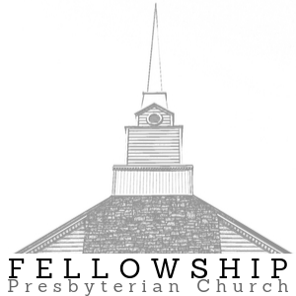
Evening Worship ~Lord’s Day~ December 8, 2019
6 PM

Wellington Manor
375 Hedrick Dr.
Newport TN

Sermon: Mark 1:40-45

