The Fellowship Digest
Edition 25, Volume 3
March 2020
The Love of God

www.fellowship-pca.org
Table of Contents
March 2020
Article: The Holy Love of God………….....…...…………3
Preaching Schedule for March……....………………..…7
Announcements…….……………………………………… 8
The Preaching of God’s Word…………………………9
Church Life: Recipes……………………………………..18
Church Life: News……….………………………………..18
Church Life: Birthdays and Anniversaries…………19
Prayer Needs…………..……………………………………21
Hymn of the Month for March……………….……….22
Hymns for March…...………..………..……….………26
Upcoming Editions of the Digest…………………..…..27
Book Recommendation…………………………………..28
Article: The Love of God……………………………..……30
Shepherding Visits for March…………………………..35
Church Calendar for March……………………..……..36

the holy love of god

By Dr. R.C. Sproul

Long ago, Augustine of Hippo pointed out that the desire of every human heart is to experience a love that is transcendent. Regrettably for us today, however, I don’t think there’s any word in the English language that’s been more stripped of the depth of its meaning than the word love. Due to the shallow romanticism of secular culture, we tend to view the love of God in the same way popular music, art, and literature view love. Yet the Bible says God’s love is far different—and greater.
First John 4:7-11 gives us this classic statement with respect to the love of God:
Beloved, let us love one another, for love is from God, and whoever loves has been born of God and knows God. Anyone who does not love does not know God, because God is love…. In this is love, not that we have loved God, but that he loved us and sent his only Son to be the propitiation for our sins. Beloved, if God so loved us, we also ought to love one another.
Here the Apostle grounds his admonition for Christians to love one another in the very character of God. “Love is from God,” he tells us. What he means is that Christian love comes from God Himself. This love is not natural to fallen humanity. It originates in God and is a divine gift to His people. When we are transformed by the power of the Holy Spirit, we are given a capacity for this supernatural love that has God as its source and foundation. When John says that “whoever loves has been born of God and knows God,” he is not teaching that every human being who loves another is therefore born of God. The kind of love of which he speaks comes only from regeneration. Without the Holy Spirit’s transformation of the human heart, no one has this capacity for love. No unregenerate person has this kind of love, and no regenerate person lacks such love. Therefore, a person who does not have the ability to love in the way John describes has not been born again. “Anyone who does not love [in this manner] does not know God.”
John does not stop there. Not only is love from God but God is love. Note that John does not use the word is as an equals sign. We cannot reverse the subject and the predicate in God is love and say love is God. John is not making a crass identification between love and God so that anyone who has a romantic feeling in his heart or any affection for another person has thereby encountered God. When he says God is love, he’s using a bit of hyperbole. In other words, love is such an intimate aspect or attribute of the character of God, that you can, in a manner of speaking, say that He is love. Any view of Him that neglects to include within it this profound sense of divine love is a distortion of who God is.
Of course, the normal problem we face is not that people ignore God’s love; rather, people separate His love from His other attributes. I don’t know how many times I’ve taught on God’s sovereignty, holiness, or justice, only to hear the objection, “But my God is love”—as if God’s love is incompatible with justice, sovereignty, or holiness.

Our most fundamental inclination as fallen human creatures is to exchange the truth that God reveals about Himself for a lie, and to serve and worship the creature rather than the Creator (Rom. 1:18-32). We commit idolatry every time we substitute a lesser concept for His glory, whether that substitution takes the crass form of stone gods or the more sophisticated form of redefining God’s character to suit our tastes. A god stripped of justice, of holiness, of sovereignty, and the rest is as much an idol as a statue of wood or stone. We must be careful not to substitute for the biblical God a god who is exhausted in his character by the one attribute of love, especially as popular culture defines it.
As Christians we believe in a God who is simple and not made up of parts. God is not one part sovereign, one part just, one part immutable, one part omniscient, one part eternal, and one part loving. Rather, He is all of His attributes at all times. To understand any single attribute, we must understand it in relation to all His other attributes. The love of God is eternal and sovereign. The love of God is immutable and holy. We treat all of His other attributes in the same way. God’s justice is loving and eternal. His holiness is loving and omniscient. Our concept of the love of God will stay on track only as we understand His love in relationship to His other attributes.
Whatever else God’s love is, it is holy. His love is therefore characterized by the qualities that define holiness—transcendence and purity. First, God’s love is transcendent. It is set apart and different from everything we experience in creation. Second, God’s love is pure. His love is absolutely flawless, having no selfishness, wickedness, or sin mixed in with it. God’s love is not ordinary or profane. It is a majestic, sacred love that goes far beyond anything creatures can manifest. No shadow of evil covers the brightness of the pure glory of the love of God.
The love of God is in a class by itself. It transcends our experience. Nevertheless, it is a love that He shares in part with us and expects us to manifest to each other. He grants to His people—insofar as is possible given the Creator-creature distinction—His holy love (Rom. 5:5).

Note: This article is used with permission from Ligonier Ministries. The full article can be found at https://www.ligonier.org/learn/articles/holy-love-god/

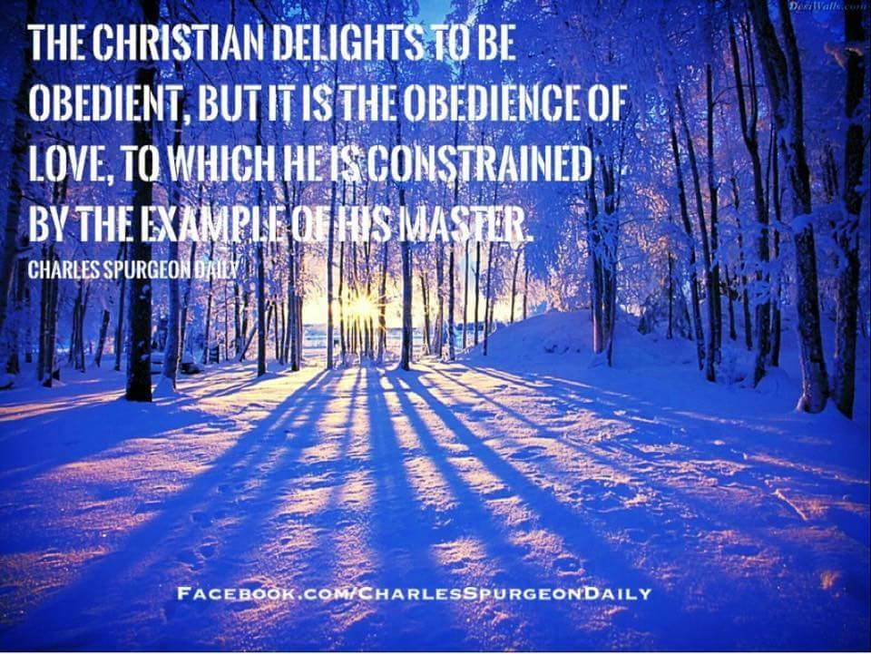
~Preaching Schedule for March 2020~
March 1 AM: Psalm 37
PM: Judges 2:6-23
March 8 AM: Hebrews 7:11-19
PM: TBD [Wellington]
March 15 AM: Hebrews 7:20-25
PM: Judges 3:1-31
March 22 AM: Hebrews 7:26-28
PM: Judges 4:1-24

March 29 AM: Hebrews 8:1-6
PM: Judges 5:1-31
~Announcements~
- Reminder: The Session is asking that all members attend all stated meetings of the church unless providentially hindered.
- The pulpit ministry of Fellowship is on SermonAudio. You can access the sermons preached by our pastor on the Fellowship website at www.fellowship-pca.org or go to http://www.sermonaudio.com/fellowship-pca
- The bulletins for the services of the church are now available on the church website.
- The pastor can be heard on the radio each Tuesday from 10-10:30 AM on WLIK. You can listen locally at 97.9 FM, 1270 AM or stream it over the internet at www.wlik.net.
- Every second Sunday evening of the month, Fellowship will be hosting a worship service for the residents of Wellington Manor. We will meet there at 6 PM.
- The church library is now open. Please take a look!
- REMINDER: Every FINAL Lord’s Day of the month, we will worship at 2 PM, immediately after the fellowship lunch.
- Please secure your copy of the March prayer calendar. It is available on the table in the hallway.
- If you would like to receive hard copies of the “Bible Reading Guide,” please sign up on the form on the table.

~The Preaching of the Word of God~
Westminster Larger Catechism – Q160
Q. 160. What is required of those that hear the word preached?
A. It is required of those that hear the Word preached, that they attend upon it with diligence, preparation, and prayer; examine what they hear by the Scriptures; receive the truth with faith, love, meekness, and readiness of mind as the Word of God; meditate, and confer of it; hide it in their hearts, and bring forth the fruit of it in their lives. F
of it in their lives. 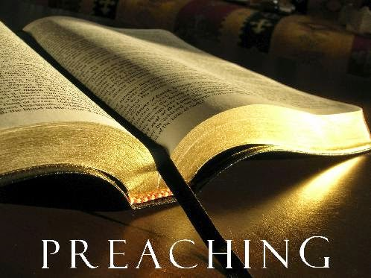
Note: Each month, to help us prepare for worship and the preaching of God’s Word, the pastor will be offering a summary of the upcoming sermons. These will include discussion questions that can be used for family or personal worship.
~March 1 – AM Worship~
Sermon Text: Psalm 37
Main Point: The Psalmist offers comfort and counsel regarding the activities of wicked people.
Discussion Questions:
- Who is the author of the psalm?
- What is the apparent issue facing the psalmist?
- What is the counsel of this psalm? Why?
- What is the comfort of this psalm? List them.
- In what ways do you fret because of evildoers? What should you do instead?

~March 1 – PM Worship~
Sermon Text: Judges 2:6-23
Main Point: The unfaithfulness of the people compared with the kindness of the LORD.
Discussion Questions:
- Why does the writer tell us about the death of Joshua at this point in the narrative?
- 2:10 states that another generation was raised that did not know the LORD. How is that possible? What must happen if the next generation is to know and fear the LORD?
- Describe the unfaithfulness of the people. What is the central sin?
- How does God help His people despite their unfaithfulness?

~March 8 – AM Worship~
Sermon Text: Hebrews 7:11-19
Main Point: Jesus and Melchizadek are compared.
Discussion Questions:
- The writer starts this passage with an “if” question. Why do you think he does so?
- From what tribe did Jesus descend? Why is that a problem if He is to be the High Priest? How is this problem resolved
- Why is the priesthood of Christ better than the one that went before under the law?
~March 8 – PM Worship~
Sermon Text: TBD
Worship at Wellington Manor
~March 15 – AM Worship~
Sermon Text: Hebrews 7:20-25
Main Point: Jesus is the guarantor of a better covenant.
Discussion Questions:
- What is an oath? How does that definition bear on this passage?
- The writer states that the priests of the old covenant were made such without an oath. How did they become priests?
- Jesus is made a better priest by way of an oath. What is the oath?
- What is the “better covenant?”
- According to this passage, what are the differences between the old covenant priesthood and the one held by Christ?
- How is Jesus able to save to the “uttermost”? Why was that impossible for the old covenant priests?

~March 15– PM Worship~
Sermon Text: Judges 3:1-31
Main Point: The LORD allows enemies to remain in the land to teach his people.
Discussion Questions:
- Who are the three judges mentioned in this chapter? Why is so little space devoted to the third judge?
- Why does the LORD leave the nations in the land? What does that teach God’s people today regarding why we are left in the world?
- What is the repeated line that introduces the first two judges in this chapter? What is the repeated action of the people? How does God respond to them?
- The picture repeated throughout the book of judges is as follows: sin, judgment, repentance, relief. How does that occur in this chapter?
~March 22 – AM Worship~
Sermon Text: Hebrews 7:26-28
Main Point: The perfect priest, who is also a Son, is suited for his people.
Discussion Questions:
- How does the writer to the Hebrews describe Christ as a high priest? How does that differ from the earthly priests?
- Why does Jesus, as the great high priest, have no need to offer sins for himself?
- What does the writer mean when he states, “He has no need, like those high priests, to offer sacrifices daily, first for his own sins and then for those of his people, since he did this once for all when he offered up himself”?
- What does this verse say about the Mass of the Roman Catholic church?

~March 22 – PM Worship~
Sermon Text: Judges 4:1-24
Main Point: The need for salvation.
Discussion Questions:
- Who are the main people in this chapter?
- Why did the people do what was evil in the sight of the LORD? See 4:1. What does that teach, in principle, about the need God’s people have for godly leaders?
- Who is Deborah, and why is she involved in the narrative in the first place?
- How does the story of the defeat of Sisera display God’s salvation?
- How does God use means to rescue his wayward people?

~March 29 – AM Worship~
Sermon Text: Hebrews 8:1-6
Main Point: The ministry of Jesus, the great high priest, in the heavenly sanctuary, is pictured.
Discussion Questions:
- Where is Jesus, the great high priest, ministering today?
- How does the writer to the Hebrews describe this heavenly sanctuary? What image is being drawn upon that the readers/listeners would have understood?
- What is the “true tent” as mentioned in 8:2? What is the copy of the “true tent?”
- Why is the ministry of the new covenant better according to 8:6?
~March 29 – PM Worship~
Sermon Text: Judges 5:1-31
Main Point: The victory of God’s people lead to praise in song.
Discussion Questions:
- Why do Deborah and Barak sing to the LORD?
- How does this chapter offer an example to God’s people today as to why we sing in worship?
- How is the LORD described in this song of praise?
- How is Jael described in this song of praise?
- How is this song both praise and prayer? See 5:31.

At Fellowship Presbyterian Church, we believe that the preached Word is central to our worship. It is to be attended to with diligence and care. The Word of God preached is the living and active voice of the Lord Jesus Christ to His people.
Q. 88. What are the outward and ordinary means whereby Christ communicateth to us the benefits of redemption?
A. The outward and ordinary means whereby Christ communicateth to us the benefits of redemption, are his ordinances, especially the word, sacraments, and prayer; all which are made effectual to the elect for salvation. (Westminster Shorter Catechism)

Services
Wednesday
6 PM Prayer Meeting and Bible Study
Current Study: One Lord, One Plan, One People: A Survey of the Bible.
Lord’s Day
9:45 AM Sunday School
11 AM Worship
The Letter to the Hebrews
5 PM Worship
6 PM @Wellington Manner [2nd Sun. of the month]
2 PM [Final Sun. of the month]
The Book of Judges

~Church Life~
~Recipes~
Do you have a recipe to share with the congregation?
PLEASE HELP our church family with a recipe or two to share in the newsletter.
Send it to wfhill@fellowship-pca.org

~Church & Community
- Wednesday Bible Study – “One Lord, One Plan, One People: A Survey of the Bible” – Everyone is invited to this study! Currently, we are examining the book of Numbers.
- The Men’s Breakfast and Bible Study is held every other Saturday from 8:30-9:30 AM. The next meeting is on March 7th at 8:30 AM.
- Starting with the April Edition of the Digest will include book reviews. Some of them will be on books in our church library.
- SUNDAY SCHOOL NEWS: Currently, the pastor is teaching on the subject of “corporate worship.” Everyone is encouraged to attend!
- MARK your calendar! Italian Night at the church: Saturday, March 28, 2020. A sign-up sheet will be available soon. Pastor Hill will be cooking the main dish.

~Church Life~
~Birthdays and Anniversaries~

Birthdays
3/3 – Pastor Hill
Anniversaries

NONE
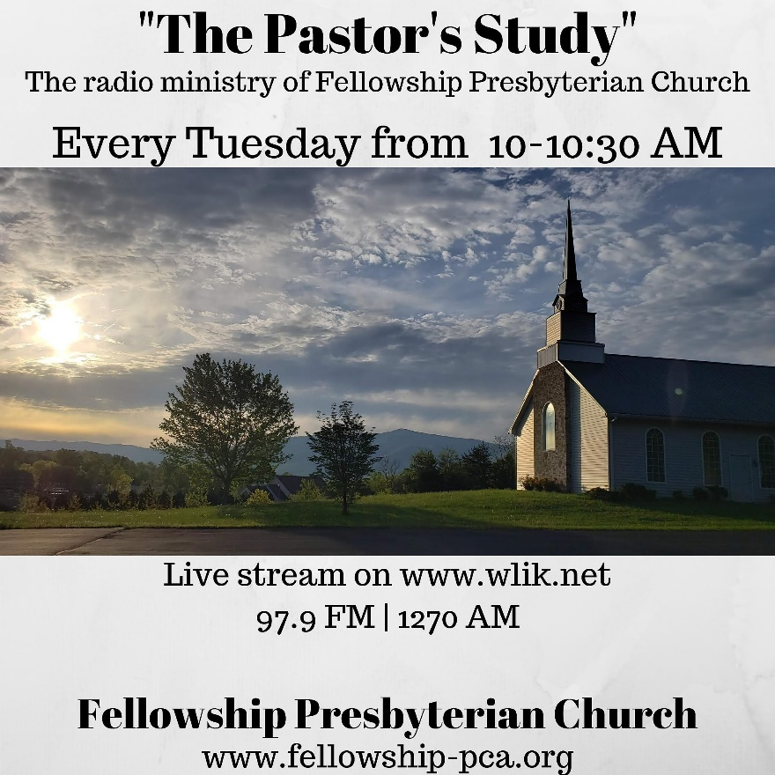

Tune in each Tuesday!
10 AM

~Prayer~

If you have any prayer needs that you would like included in the newsletter, please let one of the elders or the pastor know.
Please submit them by March 27, 2020, by 5 PM to be included in the February Fellowship Digest.
- Pray for the preaching of God’s Word.
- Pray for growth, spiritually, and numerically.
- Pray that FPC would be useful salt and light in the community to the glory of God, our Father.
- Pray for the elders of the church: protection from Satan’s attacks, wisdom, and godliness.
- Pray for the deacon and elder candidates and their training.
- Pray for those in our number who are suffering physically. NOTE: A phone call, a card, a note to them to encourage them is strongly recommended.
~Hymn of the Month~
Thy Works, Not Mine, O Christ
Trinity Hymnal #524
This hymn will be used in worship throughout March.

1 Thy works, not mine, O Christ,
speak gladness to this heart;
they tell me all is done;
they bid my fear depart.
Refrain:
To whom, save thee, who canst alone
for sin atone, Lord, shall I flee?
2 Thy pains, not mine, O Christ,
upon the shameful tree,
have paid the law's full price
and purchased peace for me. [Refrain]
3 Thy cross, not mine, O Christ,
has borne the awful load
of sins that none in heav'n
or earth could bear but God. [Refrain]
4 Thy righteousness, O Christ,
alone can cover me:
no righteousness avails
save that which is of thee. [Refrain]

About the Author:
Bonar, Horatius, D.D. Dr. Bonar's family has had representatives among the clergy of the Church of Scotland during two centuries and more. His father, James Bonar, second Solicitor of Excise in Edinburgh, was a man of intellectual power, varied learning, and deop piety.
Horatius Bonar was born in Edinburgh, Dec. 19th, 1808; and educated at the High School and the University of Edinburgh. After completing his studies, he was "licensed" to preach, and became assistant to the Rev. John Lewis, minister of St. James's, Leith. He was ordained minister of the North Parish, Kelso, on the 30th November, 1837, but left the Established Church at the "Disruption," in May, 1848, remaining in Kelso as a minister of the Free Church of Scotland. The University of Aberdeen conferred on him the doctorate of divinity in 1853. In 1866 he was translated to the Chalmers Memorial Church, the Grange, Edinburgh; and in 1883 he was chosen Moderator of the General Assembly of of the Free Church of Scotland.

Dr. Bonar's hymns and poems were, he tells us, composed amid a great variety of circumstances; in many cases he cannot himself recall these circumstances; they also appeared in several publications, but nearly all have boen published or republished in the following:— (i) Songs for the Wilderness, 1843-4. (2) The Bible Hymn Book, 1845. (3) Hymns, Original and Selected, 1846. (4) Hymns of Faith and Hope, First Series, 1857; Second Series, 1861; Third Series, 1866. (5) The Song of the New Creation, 1872. (6) My Old Letters, a long poem, 1877. (7) Hymns of the Nativity, 1879. (8) Communion Hymns, 1881. In addition to numerous prose works, he has also edited The New Jerusalem; a Hymn of the Olden Time, 1852, &c.
Dr. Bonar's poems—-including many beautiful lyrics, several psalm versions, and translations from the Greek and Latin, a large number of hymns, and a long meditative poem—-are very numerous, too numerous, perhaps, for their permanent fame as a whole.
Dr. Bonar's scholarship is thorough and extensive; and his poems display the grace of style and wealth of allusion which are the fruit of ripe culture. Affected very slightly by current literary moods, still less by the influence of other religious poetry, they reveal extreme susceptibility to the emotional power which the phases of natural and of spiritual life exercise; the phases of natural life being recognised chiefly as conveying and fashioning spiritual life, used chiefly for depicting spiritual life, and handled for this purpose with greater delicacy of touch than in the Olney Hymns, and with less conscious purpose than in the Christian Year. As a result of this susceptibility, and from habitual contemplation of the Second Advent as the era of this world's true bliss, his hymns and poems are distinguished by a tone of pensive reflection, which some might call pessimism. But they are more than the record of emotion; another element is supplied by his intellectual and personal grasp of Divine truth, these truths particularly:—The gift of a Substitute, our Blessed Saviour; Divine grace, righteous, yet free and universal in offer; the duty of immediate reliance upon the privilege of immediate assurance through that grace; communion with God, especially in the Lord's Supper, respecting which he insists on the privilege of cherishing the highest conceptions which Scripture warrants; and finally, the Second Advent of our Lord: by his vigorous celebration of these and other truths as the source and strength of spiritual life, his hymns are protected from the blight of unhealthy, sentimental introspection.
To sum up: Dr. Bonar's hymns satisfy the fastidious by their instinctive good taste; they mirror the life of Christ in the soul, partially, perhaps, but with vivid accuracy; they win the heart by their tone of tender sympathy; they sing the truth of God in ringing notes; and although, when taken as a whole, they are not perfect ; although, in reading them, we meet with feeble stanzas, halting rhythm, defective rhyme, meaningless Iteration; yet a singularly large number have been stamped with approval, both in literary circles and by the Church.

In Great Britain and America nearly 100 of Dr. Bonar's hymns are in common use. They are found in almost all modern hymnals from four in Hymns Ancient & Modern to more than twenty in the American Songs for the Sanctuary, N. Y., 1865-72. The most widely known are, "A few more years shall roll;" "Come, Lord, and tarry not;" "Here, O my Lord, I see Thee face to face;" "I heard the Voice of Jesus say;" "The Church has waited long;" and "Thy way, not mine, O Lord." [Taken from hymnary.org]
Do you have a favorite hymn that you would like included in worship? Let the pastor know!

~Scheduled Hymns for March 2020~

Note: These hymns will be used in worship throughout March. Please review them. You are encouraged to ask the pastor for a free Trinity Hymnal for your personal use at home and in family worship.

March 1
AM Worship: 1, 524, 308
PM Worship: 110.32, 119
March 8
AM Worship: 660, 524, 521
PM Worship: Worship at Wellington Manor
March 15
AM Worship: 100, 524, 535
PM Worship: 38, 460, 482
March 22
AM Worship: 30, 524, 690
PM Worship: 5, 693, 92
March 29
AM Worship: 2, 524, 176
PM Worship: 4, 604, 598

~Scheduled Topics for
The Fellowship Digest ~
March: The Love of God
April: The Wrath of God
May: Salvation
June: Christian Baptism
July: Church History
August: Moses
September: David
October: Peter
November Paul
December: The Church
Electronic editions of The Fellowship Digest are available on the church website
~Book Recommendation ~
The Love of Christ by Richard Sibbes.
From the Banner of Truth website:
The Puritan John Dod wrote that this book is ‘so full of heavenly treasure, and such lively expressions of the invaluable riches of the love of Christ’ that it kindles ‘in the heart all heavenly affections unto Jesus Christ.’ Indeed it does! And that was very much what Richard Sibbes (1577-1635) was about in all his ministry.
The Love of Christ is a series of sermons preached on Song of Solomon 4:16-6:3. For Sibbes, this Bible book ‘is nothing else but a plain demonstration and setting forth of the love of Christ to his church, and of the love of the church to Christ.’ The Song of Solomon does not simply mouth a doctrine: its sensuous imagery sings its message. It is as if this love story is played on violins. The reader is thus brought, not simply to understand, but to taste and share the delights of the lovers. This is precisely what Christ’s people need, as Sibbes knew: it is not enough to be aware of Christ’s love; we must sense, grasp and enjoy it. Only then will we truly love the Lord our God with all our hearts.

That is one reason why so many avoid books like this one: they want information, and they want it fast. But Sibbes intends to affect you, to hold your eyes on Jesus that you might develop a stronger appetite for him. Such work cannot be fast work, but it is profoundly transforming.

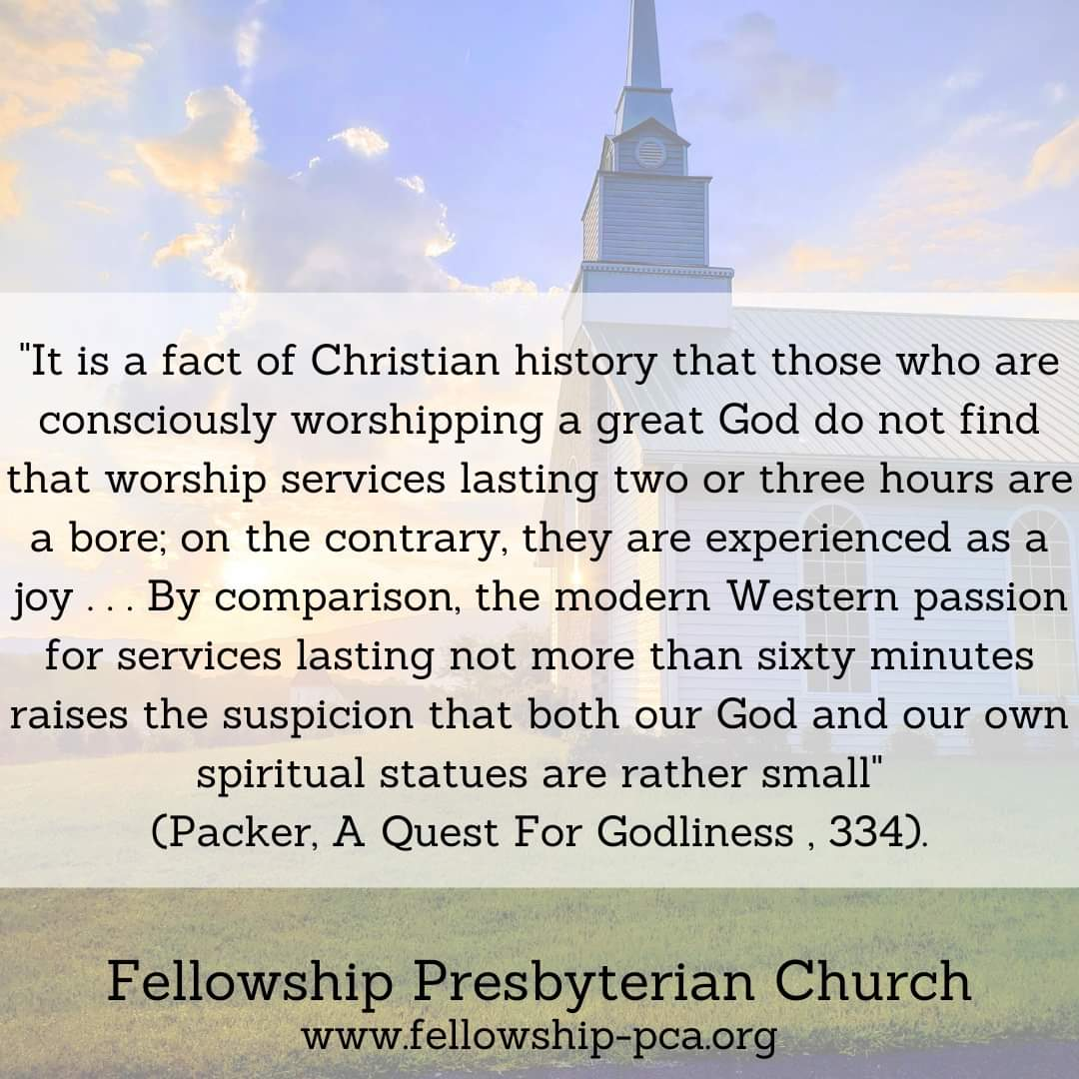

~Article ~
The Love of God

By D.A. Carson
The picture the Bible presents of God’s love is one in which His love, even in eternity past, even before the creation of anything, is other-oriented. This cannot be said (for instance) of Allah. Yet because the God of the Bible is one, this plurality-in-unity does not destroy His entirely appropriate self-focus as God. Because He is God, He is therefore rightly jealous. To concede He is something other than the center of all, and rightly to be worshiped and adored, would debase His very Godhood. He is the God who, entirely rightly, does not give His glory to another (Isa. 42:8).
If this were all the Bible discloses about God, we would read in its pages of a holy God of impeccable justice. But what of love? The love of Allah is providential, which is one of the ways the Bible speaks of God. But here there is more: in eternity past, the Father loved the Son, and the Son loved the Father. There has always been an other orientation to the love of God. All the manifestations of the love of God emerge out of this deeper, more fundamental reality: love is bound up in the very nature of God. God is love.
We must mark well the distinction between the love of the Father for the Son and the love of the Son for the Father. The Father commands, sends, tells, commissions, and demonstrates His love for the Son by “showing” Him everything, such that the Son does whatever the Father does. The Son obeys, says only what the Father gives Him to say, does only what the Father gives Him to do, comes into the world as the Sent One, and demonstrates His love for the Father precisely by such obedience. Not once is there any hint that the Son commissions the Father. Not once is there a hint that the Father submits to the Son or is dependent on Him for His own words and deeds. Historically, Christians avoiding the trap of Arianism have insisted that the Son is equal with the Father in substance or essence, but that there is an economic or functional subordination of the Son to the Father.
What is of interest to us for our topic is the way the texts distinguish how the love of the Father for the Son is manifested, and how the love of the Son for the Father is manifested — and then how such love further functions as lines are drawn outward to elements of Christian conduct and experience. These function in various ways. There is space to reflect on only one of them.
In John 15, Jesus tells His disciples, “As the Father has loved me, so have I loved you” (15:9). Thus, we move from the intra-Trinitarian love of the Father for the Son to the Son’s love of His people in redemption. Jesus thus becomes the mediator of His Father’s love. Receiving love, so has He loved. Then He adds, “Abide in my love. If you keep my commandments, you will abide in my love, just as I have kept my Father’s commandments and abide in his love” (15:9b–10).
Reflect on the parallelism. The perfection of Jesus’ obedience in the Godhead, which we have just been told is the mark of the Son’s love for His Father (14:31), is precisely what it means for the eternal Son to remain in the love the Father has for Him. This is a relational matter (the Father and the Son are related to each other in this way), but it is also a constitutional matter (that is the way God Almighty is constituted). This pattern of love, both relational and constitutional, in the very being of God becomes, according to Jesus, the model and incentive of our relation to Jesus. If we love Him, we will obey Him (14:15); here, if we obey Him, we remain in His love. Thereby our relation to Jesus mirrors the relation of Jesus to His heavenly Father — which is, of course, a major theme in John 17.
Then the passage explicitly harks back to John 5. Jesus says, “You are my friends if you do what I command you. No longer do I call you servants, for the servant does not know what his master is doing; but I have called you friends, for all that I have heard from my Father I have made known to you” (15:14–15).
Observe that Jesus makes a distinction between slaves (douloi; not “servants”) and friends. But the distinction initially surprises us. We are Jesus’ friends if we do what He commands. This sounds rather like a definition of a slave. Certainly such friendship is not reciprocal. I cannot turn around to Jesus and thank Him for His friendship and tell Him He is my friend, too, if He does everything I command Him. Strange to tell, not once is Jesus or God ever described in the Bible as our friend. Abraham is God’s friend; the reverse is never stated.
Of course, in one sense, Jesus is the best friend a poor sinner ever had. Nevertheless, that is not the terminology of Scripture, almost as if the Bible is reluctant to descend into the kind of cheap intimacy that brings God or Jesus down to our level. In this context, what then is the difference that Jesus is drawing between slave and friend? Our culture teaches that the slave obeys, and the friend may or may not; clearly, however, that is not the distinction Jesus has in mind.
He says we are His friends because He has made known to us all that He learned from His Father. An army colonel tells a GI to fetch the Hummer. If the GI says he will do so only if the colonel tells him exactly why and gives him permission to use it as a runabout while the colonel spends his time at HQ, that GI is asking for about six months of KP duty. But suppose the colonel has been a friend of the GI’s family for years and has watched the young man grow up. He may say to the GI: “Jim, fetch the Hummer, please. I need you to drive me to HQ. I’ll be there about two hours. You can use the vehicle in that gap, provided you’re back to pick me up at 1600 hours.” In this case, of course, the GI is required no less to obey the colonel. The difference, the difference of friendship, is that full information has been conveyed. It is an informational difference, a difference of revelation, not a difference of obedience.
God’s people are no longer slaves. At this point in redemptive history, the fullness of God’s revelation has come to us in the Son who was perfectly obedient and thereby perfectly disclosed God. We are no longer slaves (a redemptive-historical marker), but friends. And what has brought this change about is that in the fullness of time, God sent His Son into the world, and the Son obeyed; that the Father, in love for the Son, determined that all should honor the Son even as they honor the Father; and that the Father and Son, in perfect harmony of plan and vision, at the time God ordained, played out their roles — the Father sending, commissioning, “showing,” and the Son coming, revealing, disclosing what had been “shown” Him and in obedience going to the cross. And we heirs of the new covenant are unfathomably privileged to be let in on this stupendous plan. We are the friends of God.
We are the friends of God by virtue of the intra-Trinitarian love of God that so worked out in the fullness of time that the plan of redemption, conceived in the mind of God in eternity past, has exploded into our space-time history at exactly the right moment. When the time had fully come, as Paul puts it, God sent His Son (Gal. 4:4). And we have been incalculably privileged not only to be saved by God’s love, but to be shown it, to be informed about it, to be let in on the mind of God. God is love; and we are the friends of God.
Note: This article is used with permission from Ligonier Ministries. The full article can be found at https://www.ligonier.org/learn/articles/the-love-of-god/

~Shepherding Visits for March ~

Amick
Hill, Sr.
Jones-Curtis

~Church Calendar for March ~

Lord’s Day, March 1
1

9:45 AM Sunday School
11 AM Worship and the Lord’s Supper
5 PM Worship

Tuesday, March 3
3

10 AM Radio Program on WLIK

Wednesday, March 4
4

6 PM Prayer Meeting and Bible Study

Saturday, March 7
7
8:30 AM Men’s Breakfast and Study

Lord’s Day, March 8
8

9:45 AM Sunday School
11 AM Worship
1-4 PM Food & Fellowship (Pastor’s home)
6 PM Worship (Wellington Manor)

Tuesday, March 10
10

10 AM Radio Program on WLIK

Wednesday, March 11
11

6 PM Prayer Meeting and Bible Study

Lord’s Day, March 15
15

9:45 AM Sunday School
11 AM Worship
5 PM Worship

Tuesday, March 17
17

10 AM Radio Program on WLIK

Wednesday, March 18
18

6 PM Prayer Meeting and Bible Study

Thursday, March 19
19

10 AM Session Meeting

Saturday, March 21
21

8:30 AM Men’s Breakfast and Study

Lord’s Day, March 22
22

9:45 AM Sunday School
11 AM Worship
5 PM Worship

Tuesday, March 24
24

10 AM Radio Program on WLIK

Wednesday, March 25
25

6 PM Prayer Meeting and Bible Study

Saturday, March 28, 2020
28

6 PM Italian Night at the Church

Lord’s Day, March 29
29

9:45 AM Sunday School
11 AM Worship
2 PM Worship

Tuesday, March 31
31

10 AM Radio Program on WLIK

~Notes ~

The Fellowship Digest is a publication of Fellowship Presbyterian Church
2331 Early Rd., Newport TN 37821
Phone: (423) 623-8652
www.fellowship-pca.org
Session
Terry Rowekamp (Clerk), Rev. William Hill (moderator)
Diaconate
William F. Hill, Sr. (treasurer)

