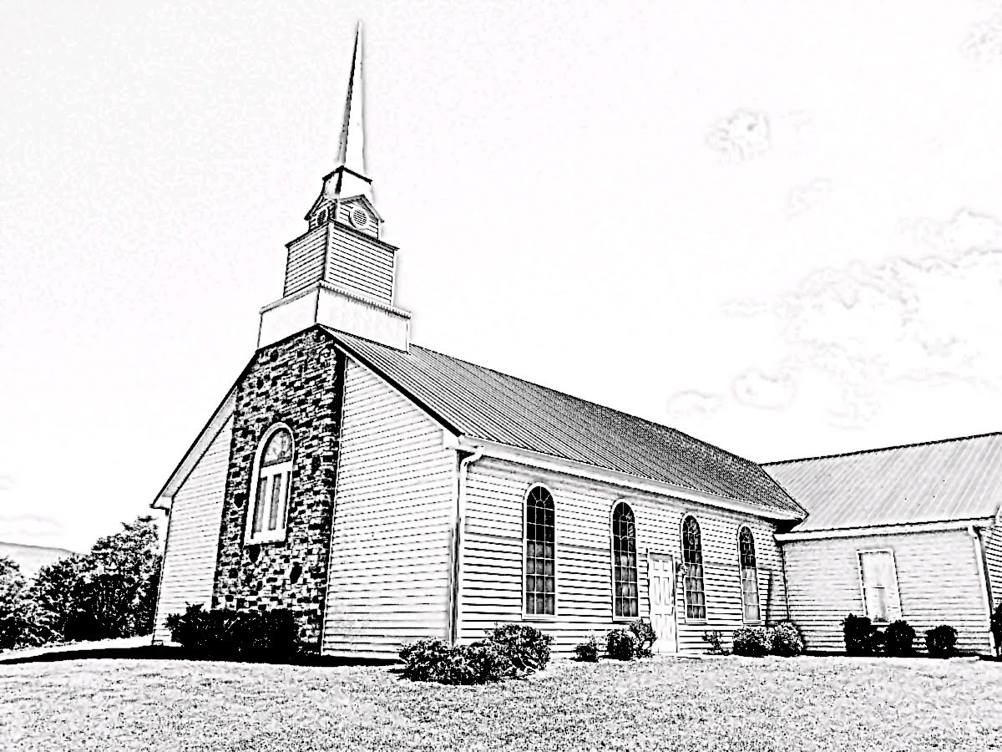
Fellowship Presbyterian Church
A Congregation of the Presbyterian Church in America
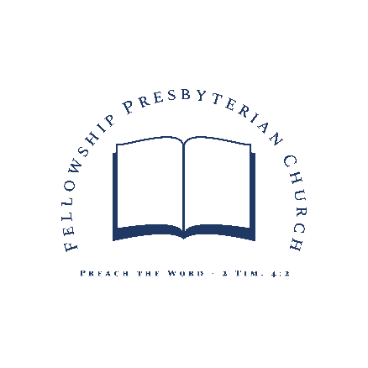
Lord’s Day ~ August 2, 2020
Rev. William F. Hill, Jr., Pastor
Morning Worship ~Lord’s Day~ August 2, 2020
~Worship in Praise~
Call to Worship Psalm 136:1-3
Prayer of Invocation
§Hymn #3 Give to Our God Immortal Praise
Hymn of the Month ~ Based on Psa. 136
~Worship in Confession~
Reading of Scripture Genesis 42
Confession of Sin See Page 3
Assurance of Pardon Isaiah 55:6-7, ESV
§Hymn #168 I Greet Thee, Who My Sure Redeemer Art
Confession of Faith Westminster Larger Catechism Q168
See Page 4
~Worship in Gratitude and Thanksgiving~
Prayer of Thanksgiving RE Terry Rowekamp
§Doxology
~Worship and the Means of Grace~
Pastoral Prayer
Reading of Scripture Romans 13:1-10
The Preaching of God’s Word Rev. William F. Hill, Jr.
The Debt of Love
Sacrament of the Lord’s Supper
§Hymn #433 O God of Mercy, God of Might
§Benediction
~Morning Worship – Confession of Sin~
Congregation:
Our most holy God, we bless your Name this morning as the God who loves to forgive sin. We thank you that you have not treated us as our sins deserve. We grieve how far short of your glory we fall each day. Forgive us for not loving our neighbor as you have taught us and commanded us. Grant to us your Holy Spirit so we may love our neighbors from the heart as we love ourselves. We ask this in the Name of the Lord Jesus Christ. Amen.
Assurance of Pardon:
Seek the Lord while he may be found; call upon him while he is near; let the wicked forsake his way, and the unrighteous man his thoughts; let him return to the Lord, that he may have compassion on him, and to our God, for he will abundantly pardon.
Isaiah 55:6-7, ESV

~Morning Worship ~ Confession of Faith~
Westminster Larger Catechism Q168
Q. 168. What is the Lord's supper?
A. The Lord's supper is a sacrament of the New Testament, wherein, by giving and receiving bread and wine according to the appointment of Jesus Christ, his death is showed forth; and they that worthily communicate feed upon his body and blood, to their spiritual nourishment and growth in grace; have their union and communion with him confirmed; testify and renew their thankfulness, and engagement to God, and their mutual love and fellowship each with other, as members of the same mystical body.

~Church Announcements and Calendar~
- REMINDER: When you hear the piano playing, please find your seat and prepare for worship.
- We are celebrating the Sacrament of the Lord’s Supper TODAY in the morning worship service.
- If you are interested in becoming a member of Fellowship, please see the Pastor.
- REMINDER: the Session is calling a congregational meeting for Aug. 30th immediately after the AM Worship service to vote on the recommendation of the elders to elect Randall Sheetz to the office of Ruling Elder.
Lord’s Day, August 2, 2020
11 AM & 5 PM Worship | Lord’s Supper (AM Worship)
AM: Rom. 13:8-10 | PM: Judges 7:19-25
Tuesday, August 4, 2020
10 AM Radio Program on WLIK
Wednesday, August 5, 2020
6 PM Prayer Meeting and Bible Study
The Doctrine of Providence, part one
Thursday, August 6, 2020
6:30 PM Westminster Standards Study
Lord’s Day, August 9, 2020
11 AM & 5 PM Worship
AM: Romans 13:11-14 | PM: Judges 8:1-35
~Prayer Needs~
Family of the week: Bill Sr. and Sandra Hill
Church of the week: Crosspoint (Boone NC)
~Ushers, Greeters and Nursery Volunteers~
August Ushers: TBD
Greeter: TBD
Nursery: TBD
~Church Information~
Session: Terry Rowekamp (Clerk),
Rev. W. Hill, Jr. (Moderator)
Diaconate: William Hill, Sr. (treasurer)
Music: Mr. Randall Sheetz
Website: www.fellowship-pca.org
Mailing Address: PO Box 574, Newport TN 37822

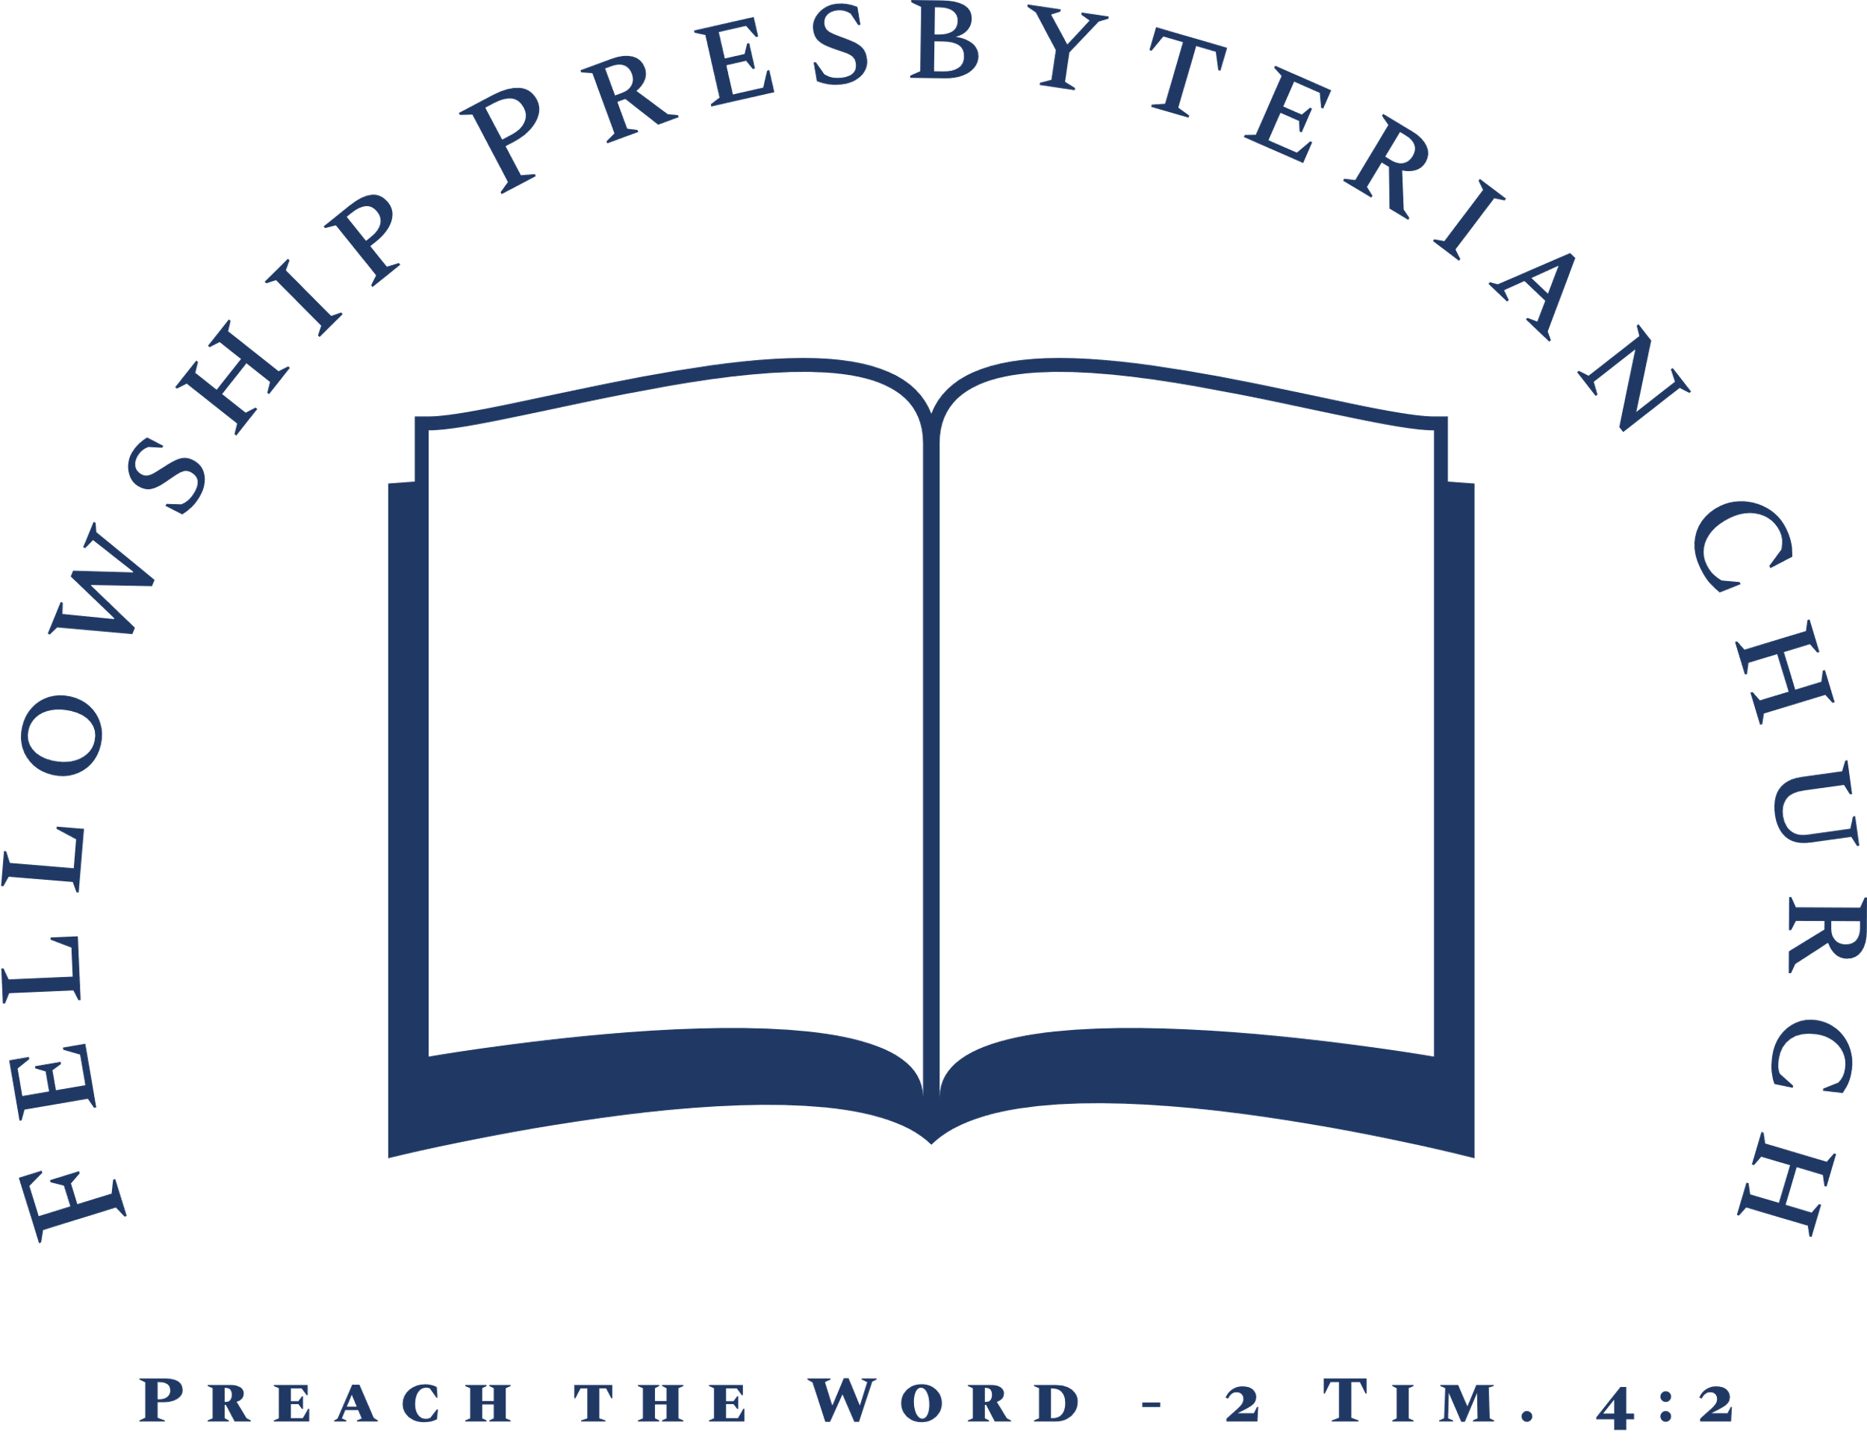
Evening Worship ~Lord’s Day~ August 2, 2020
~Worship in Praise~
Call to Worship Psalm 105:1-3
Prayer of Invocation and Confession of Sin
Hymn #2 O Worship the King
~Worship in Confession~
Confession of Faith The Apostles’ Creed
Trinity Hymnal, p. 845
Reading of Scripture John 5
~Worship in Gratitude and Thanksgiving~
Prayer of Thanksgiving Rev. William F. Hill, Jr.
Giving of Tithes and Offerings
Hymn #32 Great is Thy Faithfulness
~Worship and the Means of Grace~
Pastoral Prayer and Prayer of Illumination
Reading of Scripture Judges 7:19-25
Sermon Rev. William F. Hill, Jr.
Gideon’s Mighty Victory
§Hymn #92 A Mighty Fortress Is Our God
§Benediction

